Student Teaching Handbook

PREFACE
The faculty and staff of the Education Department of the University of Maine at Presque Isle believes in the power of teachers to change lives and make the world a better place through education. Our goal is to develop, inspire and guide students who share our vision. Our faculty are dedicated teachers who are committed to students and believe that our students learn through hands-on, action study through the student teaching experience. This experience will provide you with the opportunity to further develop competencies requisite for becoming a successful professional educator. Upon successful completion of your student teaching program, you can expect to enter the teaching profession confidently and successfully.

The authors of this Handbook gratefully acknowledge that they have used the procedures and freely borrowed, adapted, modified, and used words phrases, ideas and concepts found in similar publications of the following educational institutions listed in alphabetical order: Augustana College, Arkansas State University, Columbus State University, Davidson College, Dordt College, Florida State University, Graceland University, Northern Michigan University, Plymouth State University, Reich College of Education, Wichita State University, University of Colorado, University of Maine, University of Maryland and University of North Carolina.

Revised April 2022

Contents

Program Goals 3
Goals of the Student Teaching Program 3

Placements 3

Student Teaching Options 4
Option A: Traditional Student Teaching Experience 4
Option B: Two-semester Internship 4
Option C: Ten-month International Experience with Stipend 4
Option D: Pathway to Student Teach while Employed as an Ed Tech 4

Placement Orientation Meeting 5

Student Teaching Period 5

School Day 5

Code of Conduct 5

Exceptions to Guidelines 5

Physical Contact with Students 6

Legal Responsibility 6

Withdrawing from Student Teaching Placement 6

Withdrawal from a Placement by the University 6

Unique Circumstances for Discontinuing a Placement 6

Activities Outside of Student Teaching 6

Student Teaching Requirements 6

What is Student Teaching All About? 9
Reporting to Assigned School 9
Responsibility to the Students 9
Responsibility to the University of Maine at Presque Isle 9
Responsibility to your Development as a Professional 9
Relationship with the Cooperating Teacher 9
Relationship with the University Supervisor 10
School Orientation 10
Teacher Observation Opportunities 10
Participation in Class and School Programs 10
Planning and Teaching 10

Maintain a Personal Student Teaching Binder 11
Section I. Official Documentation 11
Section II. Lesson Plans 11
Section III. Reflective Journals 11
Section IV. Your Formal Observations and Evaluations by University Supervisor and Cooperating Teacher 12
Section V. Student class list 12
Section VI. Evaluation of Student Teaching Experience 12

Forms & Instructions for Student Teaching Binder Section I Official Documentation 13
Form A Student Teacher Attendance Log 14
Student Teacher: School: 14
Form B Lesson Observation 15
Lesson Presentation: 15
What to look for in the lesson observation 17
Form C Documentation of participation in non-classroom activities 18

Section II – Lesson Plans 19

University of Maine at Presque Isle 22

Rubric for Lesson Plan 22
Lesson Plan- Short Form- D-3 24
CCSS/MLR/National Standard: 24
Objective: 24
Assessment: 24
Learning Activities: 24
Engagement: 24
Materials (other than standard): 24
Sources: 24
URL’s: 24
Elements of a Good Lesson Plan 25

Section III – Reflective Journals 26
Form E Reflective Journal 27
Reflective Journal Tips 28

Section IV Formal Observations and Evaluations by University Supervisor and Cooperating Teacher 29

Section V – Student Class List 30
Form G-1 Regular Education Class Student Summary Form 31
Form G-2 Special Education Class IEP Summary Form 32

Form K - Student Teacher Documentation Checklist 33

Tips For a Successful Student Teaching Experience 34

Your First Day 35

Links to Teaching Tools 36

Take Care of Yourself 37
Appendix I 38
UMPI Teacher Education Conceptual Framework 39
Opportunity 39
Knowledge 39
Reflection 39
Dispositions 39
Diversity 39

Instructional Strategies 39
Appendix II Common Core Teaching Standards 40

Appendix III Two Semester Intern Option 48
Suggested Year Plan for Elementary Interns 49
Suggested Year Plan for Secondary Interns 51

Appendix IV 53
Select the Tk20 Icon 53

Program Goals
The University of Maine at Presque Isle student teaching program is designed to foster the principle that the knowledge, dispositions, and pedagogical skills supporting the 11 Maine Common Core Teaching Standards, Maine Common Core of Learning, and the Education Department’s Conceptual Framework can be developed most effectively when the student teacher has a continuous ‘full day’ experience with a group of learners.
Student teachers involved with major responsibilities in planning, teaching, and assessing under the competent guidance of experienced teachers and university supervisors will better understand the learning process and develop competencies for future success as professional educators.

Goals of the Student Teaching Program
- Through the implementation of planning, teaching, and assessment strategies, student teachers will achieve success with the goals and objectives of the 11 Maine Common Core Teaching Standards, Maine Common Core of Learning, and the Education Department’s Conceptual Framework.
- Student teachers will demonstrate pedagogical competencies for the instruction of students with diverse needs.
- Student teachers will become an integral part of their placement school under the guidance and support of their cooperating teacher.
- Student teachers will become proficient reflective practitioners as they complete their required assignments.
- The experience of student teaching will initiate participants into a state of mind of lifelong learning and professional development.

Placements
The University of Maine at Presque Isle provides opportunities for placement in schools in Aroostook County but also in schools across the State of Maine, other states, and in international schools. The university will place students with an experienced professional educator who will serve as mentor. A university student teaching supervisor will oversee the placement.

All student teaching placements are made by the Coordinator of Student Teaching based on information from the student’s formal application for student teaching. For University of Maine at Presque Isle Education majors, this application is submitted upon successful completion of all program requirements of the teacher education program. Factors considered in making placements are:
- Student’s preferences
- Teacher Certification being sought
- Community location
- Grade level/subject area availability
- University supervisor availability
- Cooperating teacher availability
- Recommendations from advisors and faculty

Students are permitted to request specific schools, teachers, and grade levels. These requests will be honored whenever possible, but are not guaranteed. You are responsible for your own transportation to and from the school you are placed at. You should request different schools and different grade levels for a richer practicum experience. You may NOT request placements in a school where you would have relatives in the same department or in a direct line of supervision for you or your cooperating teacher. DO NOT contact schools, teachers, or building administrators regarding placements without prior authorization from the Coordinator of Student Teaching.

Student Teaching Options

Option A: Traditional Student Teaching Experience
UMPI's traditional student teaching experience rounds off a quality professional preparation by allowing students to do their practice teaching in up to two classroom settings, where they put learned theory into practice under the supervision of experienced classroom teachers and university staff. Different schools and different grade levels are recommended to provide experience with a range of skills in varied learning
environments over the course of one semester.

Option B: Two-semester Internship
UMPI has formulated partnerships with local K-12 schools who accept two-semester interns to work closely with mentor teachers. Interns spend one day per week in the school during the fall semester getting to know faculty, staff, and students while taking course work, including the EDU 395 Practicum class. During the spring semester, interns complete their student teaching in the same setting. This experience is an exceptional opportunity to grow professionally and forge long term relationships with colleagues. Students file an application with the Coordinator of Student Teaching by January 31 for participation in the following school year and are selected through an interview process. (See Appendices for a more detailed description.)

Option C: Ten-month International Experience with Stipend
For students seeking an international professional growth experience, UMPI has a long-standing partnership with the Lertlah School in Bangkok, Thailand. The student signs a ten-month contract to team teach with a Thai teacher, providing instruction in English to Thai children in a private school setting using a North American curriculum. During the first 15 weeks of this contract, the student completes student teaching and is supervised by a resident university supervisor and a member of the Lertlah administrative staff. The Lertlah School reimburses round-trip airfare and provides a stipend and housing allowance to cover living expenses for the ten-month contract. For further information, contact UMPI’s Coordinator of Student Teaching and Field Experience.

Option D: Pathway to Student Teach while Employed as an Ed Tech
For students who are currently employed as an ed tech, there is a potential option to student teach while employed in this role. This option requires permission from both the school district in which the student is employed, and also from the University. Permission from the University will be based on the following:

The student must be employed at the grade level/content area in which they are seeking their degree and/or endorsements.

The student must be able to assume the role of student teacher in the same classroom each day under the supervision of a cooperating teacher and university appointed supervisor. This option may not work if the student is working as a one-on-one and/or moving from classroom to classroom as part of their ed tech role.

Option E: Student Teaching as a Non- Degree Student
This option is for students who are not enrolled in the UMPI Education Program but would like to student teach in order to fulfill teacher certification requirements. Candidates for this option must submit the following for review:
- a student teaching application
- two letters of recommendation, one of which must come from a k-12 educator or administrator
- at least 3 credits in pedagogy-related coursework, or a minimum of 1 year working in a k-12 school as a paraprofessional or professional educator, or similar experience
- a letter from the certifying state that shows proof of all completed coursework except the student teaching component
- 3 credits in classroom management coursework and or experience with classroom management is also strongly recommended

In addition, the candidate must interview with the Education Program Director and Coordinator of Student Teaching and Field Experience.

Remote Placement: Any student seeking a variation of the traditional student teaching placement must submit a written request and meet with the Coordinator of Student Teaching to discuss the details and placement feasibility. Students will be responsible for any additional cost incurred by the university as a result of the remote placement. Such cost will be factored into the student’s tuition rate. Factors in determining the feasibility of such placements include verification that the school is accredited (in the case of private and international schools), the school’s use of a North American curriculum, availability of a classroom placement and supervision by a qualified education professional. The supervisor must be from outside of the placement school in all but extreme circumstances.

Placement Orientation Meeting
An orientation will be given for student teaching candidates near the end of the semester prior to placement. These meetings are typically held in early December and mid-April. Students will be provided with specific information regarding their placement expectations at the meeting.

Student Teaching Period
The student teaching experience will be a minimum of 75 days. If the host school should move to remote learning due to widespread illness, or for any other reason the school should deem necessary, student teaching days will still count if you are working remotely as long as you are performing assigned tasks per school remote learning protocols. Attendance documentation will be recorded on Form A Student Teacher Attendance Log. It is the student teacher’s responsibility to notify the cooperating teacher and the university supervisor of any absences. Students having absences will be required to make up the missed days. In the case of excessive absences or multiple days missed due to weather conditions, the Coordinator of Student Teaching will determine an appropriate course of action upon review. The calendar of the placement school will be observed by the student teacher. The student teacher will be expected to attend and participate in any school activity required of the cooperating teacher. Documentation of such activities will be recorded on Form C- Documentation of Participation in Non-classroom Activities. Professional seminars, conferences and workshops provided by the placement school or the university will be counted as part of the 75 day requirement.

School Day
Student teachers have the same school arrival and departure time as dictated by the placement school policy. This should be viewed as a ‘minimum’ requirement. It is expected that a student will arrive earlier and leave later as the need arises.

Code of Conduct
As a representative of the University you are expected to:
- Remember that you are a guest of the school and behave at your personal/professional best.
- Be punctual, reliable, and responsible when you are expected to be somewhere or perform a task.
- Demonstrate interest, courtesy, and appreciation for the expertise and opportunities made available to you through your host school by being attentive, and congenial.
- Turn off, or silence all electronic devices.
- Respect opinions, feelings and abilities of students, faculty, and staff.
- Familiarize yourself with host school rules and district policies.
- Use appropriate (formal, professional) language at all times.
- Demonstrate awareness and respect for issues of confidentiality and privacy.
- Maintain professional dress and hygiene consistent with the educational environment and that complies with school/district policy or expectations.

Exceptions to Guidelines
Physical education students will wear appropriate attire, approved by the faculty, during physical education instructional/observation periods.

Physical Contact with Students
Any physical contact with students is discouraged. Physical punishment is never to be used. In performance classes such as physical education, drama, art, etc. some physical guidance may be needed, but student teachers should exercise caution and reasonable judgment. Any situation that could be viewed as ‘questionable’ by observers should be avoided.

Legal Responsibility
Student teachers must exercise good judgment concerning situations and conditions that could be potentially dangerous for pupils in their care. Pupils must be directly supervised at all times. While it is expected that student teachers will perform pupil supervisory duties (playground, cafeteria, playground, etc.), this should be done in conjunction with a school employee for liability purposes.
Prevention of potential hazards is prudent and expected. Student teachers should familiarize themselves with the local school’s emergency protocols. They must also observe FERPA regulations in all situations.

Withdrawing from Student Teaching Placement
If a student decides to withdraw from student teaching, the same procedure and timeline as that set forth by the University for course withdrawal will be applied. It is the student’s responsibility to notify the Coordinator of Student Teaching of the decision to withdraw.

Withdrawal from a Placement by the University
The University reserves the right to make a reassignment, arrange for an assignment at a later date, or permanently terminate a student teaching assignment. Such decisions will be made by the University Supervisor and the Coordinator of Student Teaching following a review of all information relevant to the circumstances prompting the change. If a termination is made, a student may apply for re-admission by submitting a formal request to the Coordinator of Student Teaching. The Coordinator and the Dean will review the pertinent factors related to the dismissal and the request for re-admission. An interview with the student may be requested as part of the review. The student will be apprised of the decision for re-admission following the review.

Unique Circumstances for Discontinuing a Placement
A student teacher may apply to the Coordinator of Student Teaching for a discontinuation of placement due to unique circumstances such as personal health, family situations, illness of the cooperating teacher, etc. Such requests will be reviewed with the Dean and acted upon individually. Discontinuation of a placement for a unique circumstance will not have a negative connotation.

Activities Outside of Student Teaching
Student teaching requires a great deal of time for meeting, planning and reflection beyond the regular school day. Therefore, enrollment in other classes, employment, coaching, participation in varsity athletics, and other extracurricular activities is discouraged.

Student Teaching Requirements
Student teaching is the pinnacle experience for teacher candidates enrolled in the
Education Program at the University of Maine at Presque Isle. During this
experience, teacher candidates will be provided with opportunities to apply the
knowledge developed during coursework and field experiences while at the
University and meld theory with practice under the direct supervision of a
Cooperating Teacher in a live teaching environment. The following should take place as part of your
student teaching experience:
Conferencing with the Cooperating Teacher and the University Supervisor
Gaining familiarity with curriculum and academic content
Planning lessons and working within classroom/building schedules
Managing classroom responsibilities and performing routine duties
Teaching and working with students, employing a variety of approaches
Writing and teaching an instructional unit with an evaluation component
Constructing bulletin boards and/or instructional displays
Reflecting and evaluating personal teaching skills and dispositions
Regular check-in meetings with the Coordinator of Student Teaching
Evaluation of the Student Teacher Placement, Cooperating Teacher, and University Supervisor
A minimum of two full weeks of "solo" student teaching per placement (or three to four full weeks in the case of a full semester placement).
Additional ‘solo’ student teaching beyond minimum expectations is encouraged
Solo teaching means that the student has assumed all teaching duties and fulfills all teacher responsibilities determined to be appropriate by the cooperating teacher.

Assessment:
Continuous evaluation is an integral part of the student teaching process. It is most powerful when it is collaborative. A student teacher must critically evaluate individual teaching skills and be open to assessment and suggestions from the Cooperating Teacher and University Supervisor. The University Supervisor will make formal observations and maintain communication with the Cooperating Teacher and Student Teacher to get an accurate picture of the student’s classroom functioning. The Cooperating Teacher will also complete periodic observations and function as a day to day mentor. The Student Teacher will also maintain a weekly reflective journal to keep the supervisor informed of classroom activities, challenges, and accomplishments. This journal will be submitted electronically to the University Supervisor. The use of a shared Google document is recommended for this. Results of all these assessments will be reviewed and discussed in an effort to identify strengths and areas that need to be further developed. These assessments are tools to help the Student Teacher evaluate skills in an effort to reach full potential.

At approximately three-week intervals, the University Supervisor and the Cooperating Teacher will complete formal observations based on Maine’s 11 Common Core Teaching Standards and the Education Department Professional Dispositions. This should be a total of four formal observations. Near the end of each placement, Supervisors and Cooperating Teachers will receive an email notifying them that it is time to complete an assessment in TK-20 that is based on the formal observations that were completed. (For full-semester placements, assessments will be completed at mid-semester and near the end of the semester.) On a similar schedule and using the same forms, the Student Teacher will be expected to complete self- assessments in TK-20, but will NOT receive a notification email to that effect.
The ratings (basic, developing, proficient, distinguished) should not be equated with traditional A-B-C ratings, but rather with the idea that “proficient” should be the target. The “distinguished” rating should be reserved for truly outstanding performance—above and beyond expected performance, similar to “WOW” service in a service industry setting. This rating would be for that student who goes so far beyond expected performance that a rating is needed to set them apart from others who do a good job. No one should feel ashamed of a “proficient” rating, because this recognizes quality work; but the “distinguished” rating should be for that student who stands out among others in any of the areas assessed. Because of course preparation prior to student teaching, a ‘basic’ level of proficiency with the standards can usually be assumed. It is unexpected and unlikely that a Student Teacher would be fully proficient or distinguished in the early weeks of the first placement but, by the end of the student teaching experience, it is expected that students will be fully proficient in meeting these standards.

Student Use of TK-20
The TK-20 program allows students to upload artifacts to support their performance ratings associated with each Standard. These artifacts should be representative of the student teaching experience and can take the form of relevant portions of lesson plans, screen shots of professional development certificates, pictures of bulletin boards or displays showing student work resulting from lessons taught, video clips, etc. By the end of the semester, there must be at least three artifacts, along with their rationale, for each of the eleven standards for a total of 33 artifacts and supporting rationales.

It is important to emphasize that no one should use the SUBMIT option until the end of the semester when all materials are uploaded. There are options to ADD (or UPDATE) and to SAVE; these should both be used during the semester each time new material is added in order to be available to view what has been uploaded. Please note that when material is uploaded and saved, all three parties, in addition to the Coordinator of Student Teaching should be able to view ratings and comments.

After students, supervisors, and cooperating teachers have all uploaded assessments, a comparison of the ratings should be used collaboratively by all three parties to determine the next area(s) for the student to work on prior to the next assessment. In this way, the assessments will set the focus for the practicum. (Please see the Appendix for screen shots showing how to navigate within the TK-20 platform.)

When uploading artifacts to your TK-20 account, you should create a Word document that identifies the standard to which you refer, a two or three sentence description of what the artifact is, and a very brief statement that explains how the artifact represents your proficiency with the standard. You can then import a picture, video, screen shot, or cut and pasted text. It is recommended that you place all three artifacts, along with their rationale, in one document for each of the eleven standards for a total of eleven Word documents. Once the document is complete, it can be "dragged and dropped" into your TK-20 account under the appropriate set of standards.

You should also be sure to complete the rubric self-ratings in both the Common Core Standards tab and Dispositions tab each time the assessments come due. There is a little circle next to each rating that allows you to click on the one that best describes your current performance. There is no expectation to upload any artifacts under the Dispositions tab, though the option is there if you have something you want to include.

What is Student Teaching All About?
Student teaching could be considered to be the capstone experience in your teacher education program. It is a final opportunity to put theory into practice, to apply principles of pedagogy and methodology, and to refine performance in the classroom under the guidance and support of professional educators. Student teaching is your opportunity to grow professionally under the supervision of another teacher.

All the earlier talk about teaching becomes tested in practical reality. Student teaching is also an opportunity to earn solid recommendations, and make important job contacts.
This experience challenges you in many ways. You must make the transition from the familiar
university where you were a student to a classroom situation where you practice becoming a teacher. This metamorphosis requires you to develop professional integrity and to accept numerous responsibilities. In order to have a successful experience, you will have personal and professional obligations. You are encouraged to seek ways to distinguish yourself rather than settle for meeting minimum requirements.

Reporting to Assigned School
Days before you begin, check on the best transportation route and method for getting to your assigned school. Also, contact your cooperating teacher through the school office or via email to introduce yourself and to confirm your date of arrival. When you arrive, report to the main office, unless you made other arrangements with your cooperating teacher. Introduce yourself to the main office staff and to the principal, if possible. They will direct you to your classroom or introduce you to your cooperating teacher. Discuss with your cooperating teacher how to introduce yourself formally to the students, what roles you will play in your first week, and what ways you can immediately be helpful.

Responsibility to the Students
The first consideration of the student teacher should be the personal and academic welfare of the students you teach. Although this is a training period, you must remember that you are influencing students intellectually and emotionally. As a prospective teacher, you must strive to be a positive role model personally and professionally, relating to each pupil without prejudice or partiality.

Responsibility to the University of Maine at Presque Isle
You are a representative of the University of Maine at Presque Isle and as such will be expected to adhere to the Code of Conduct. The quality and integrity of the institution and the Education Program are affected by the manner in which you uphold our academic and professional standards during interactions with students, school staff members, and parents. As a university student, you should not engage in local school politics or union disputes.

Responsibility to your Development as a Professional
Patterns of professional behavior and teaching dispositions have been nurtured as you progressed through UMPI’s teacher preparation program. Student teaching enables you to become a more active member of the teaching profession. Use your time as a student teacher to inform yourself about professional organizations and legal aspects of the profession, focus on continual self-development, reappraise your personal values and professional goals, and act according to professional ethics. It is important that you continue this development after the conclusion of student teaching throughout your professional education career.

Relationship with the Cooperating Teacher
Your relationship with your cooperating teacher will probably be different from that established with university faculty. The daily, informal contact between student teachers and cooperating teachers often lends itself to a more personal rapport than is generally found in the university classroom. You should approach your relationship with your cooperating teacher in an open manner, while always acting with professional discretion.

You should project an interested, cooperative, and enthusiastic attitude when working with your cooperating teacher, anticipating ways to be helpful. Discuss your cooperating teacher's long-range plans for the classes you are to teach so that you may better plan individual lessons. Learn about any individual students in the classes you will teach who have special needs.

Relationship with the University Supervisor
Your university supervisor will be assigned by the Coordinator of Student Teaching. The supervisor will be responsible for evaluating your work; however, the primary role is that of a resource person linking what you have learned in pre-service courses and actual teaching. You can seek help from your supervisor in preparing lessons, consultation for improving effectiveness, and resolving ambiguities or problems in your student teaching setting. Contact arrangements should be made prior to the initiation of the placement. Your university supervisor will formally meet you at the beginning, middle and end of each placement in guiding you through the experience for a minimum of four visits.

School Orientation
Introduce yourself to other faculty and staff members. Arrange to meet the school principal and other administrators, tour the school building, including the library, staff lounge, cafeteria, art,
music, physical education rooms, and any other facilities unique to the school. Familiarize yourself with the outside compound (e.g., playground, athletic fields, out buildings) as well. If you plan to use any of these spaces with your class, inquire about school policies concerning their use. Obtain copies of school handbooks, textbooks, workbooks, or curriculum guides you can use in lesson preparations. Locate other resource materials in your assigned classroom or in the school which may be useful in lesson preparation (e.g., library and IT materials).

Teacher Observation Opportunities
Student teaching is a time to learn as much as possible about the whole school. When you have all the responsibilities of a full-time teacher, you will find little chance to observe as thoroughly as you can now. At first, observe your own classroom in order to become familiar with the students (learn their names quickly!), the group dynamics, the curriculum, and your cooperating teacher's expectations and routines. You are required to complete 4 formal observations during your time as a student teacher. While some of the observations should be of your cooperating teacher, please feel free to observe other teachers in your placement school if permitted. As you observe your cooperating teacher and other teachers, reflect upon different teaching styles.

Participation in Class and School Programs
From the first day, begin to be an active participant in the classroom. Find ways to become actively involved (tutoring, small group work, bulletin boards, etc.), participating wherever it is appropriate, in ways that are comfortable for both you and your cooperating teacher. Attend all faculty meetings, parent/teacher conferences and when feasible participate in RTI and IEP meetings, in-service meetings, extra-curricular activities, staff development programs, and professional organizations.

Planning and Teaching
Discuss your role with your cooperating teacher. When you begin, try small segments (one or a few students for a brief time and narrow purpose) and work toward larger group instruction for an extended length of time.
Experiment with a wide variety of appropriate teaching methods and materials. As you become more comfortable and competent, your cooperating teacher will yield more responsibility. Eventually, you should teach the whole group for an extended period. Meet with your cooperating teacher to discuss lesson plans prior to implementing them. Ask your cooperating teacher to observe your lessons, discuss your lesson strengths, and openly invite constructive criticism. Act upon suggestions!

Maintain a Personal Student Teaching Binder

Your personal binder organizes your student teaching materials in five sections. The binder should be available to be presented to your University Supervisor at each visitation and can be digital, or a physical binder.

Section I. Official Documentation
This section includes the official forms documenting your Student Teaching experience that are to be included in your binder.

Form A: Student Teacher Attendance Log

Form B: Observation of your Cooperating Teacher –
Observation of your cooperating teacher enables you to identify routines, procedures, and instructional strategies already employed in the classroom. Observation is more than simply watching; it is paying attention to detail, analyzing events, and assimilating ideas into your own foundation of knowledge. You should observe more than lesson presentation, noting routine procedures, classroom management techniques, transitions, etc. Record your observations and reactions formally on Classroom Observation Form B. You must include at least 4 completed Observation Forms.

Form C. Documentation of participation in other activities, teacher meetings, parent meetings, staff development activities, IEP meetings etc.

Section II. Lesson Plans
Preparation is a fundamental part of teaching. You should prepare written plans for lessons you teach as directed by your cooperating teacher and/or your university supervisor. Specific requirements for submission of plans will be established by your university supervisor and cooperating teacher. Your university supervisor will review your lesson plans and look for evidence of planning during the observation (focus on objectives, organization of materials, structure of lesson plan, etc.). The lesson plan for the lesson the university supervisor will be observing must be sent electronically at a predetermined point in time to the university supervisor but no later than 1 day in advance of the observation. You should use the lesson plan template provided in the Appendix, and use the accompanying rubric (D-2) to self-assess before sharing it with your cooperating teacher and/or University supervisor. After each lesson you should review your performance and note specific changes you plan to make to improve future presentations of similar material. Four formal lesson plans will be required (2 by mid-semester and 2 more by the end of the semester). (Form D-1) Copies of these lesson plans should be included in your binder as noted in Form K. For other lessons, you may use the shorter, Lesson Short Form template (Form D-3).

Section III. Reflective Journals
The importance of becoming a reflective teacher cannot be overstated. Keep a journal of your student teaching experiences, providing a synopsis of classroom activities and a reflection on your interactions with the students and staff. This journal is a confidential communication tool to keep your university supervisor informed of such things as classroom dilemmas, personal insights, changes in your professional philosophy, classroom accomplishments, personal frustrations, staff relationships, student accomplishments, creative lessons that you taught, difficult periods, last minute schedule adjustments that affected your teaching, etc. It also should keep the supervisor informed of conversations with the cooperating teacher and ways you have worked together to plan and solve problems. Keep daily notes to facilitate your weekly journal submission. It is recommended that you keep a running Google document that you have shared with your supervisor for your weekly journal. This journal must also be documented in your personal binder. After your student teaching this journal will also serve as a memento of this experience. (Form E can be copied and pasted into your Google Document)

Section IV. Your Formal Observations and Evaluations by University Supervisor and Cooperating Teacher
This section catalogs your progress as reported by your University Supervisor and your Cooperating Teacher. For each placement, you will have several observations and a final evaluation completed by your Cooperating Teacher and your University Supervisor in TK-20. At mid-semester and near the end of the semester, you will complete a self-assessment in TK-20 and upload artifacts supporting each standard.

Section V. Student class list
As a teacher you must be knowledgeable about students’ diverse needs. This section will provide you with an opportunity to review each student’s educational records and establish the unique needs of each student. Discuss the Family Education and Privacy Act (FERPA) requirements with your cooperating teacher before reviewing student records.

(Form G 1 Regular Education Form G 2 Special Education)

Section VI. Evaluation of Student Teaching Experience
You will evaluate your Student Teaching Experience on TK-20 as follows: Mid-semester: Evaluation of Cooperating Teacher I (this is only if you have two placements- otherwise, you will complete the evaluation at the end of the semester)
End of Semester: Evaluation of Cooperating Teacher II
Evaluation of University Supervisor
Evaluation of the Effectiveness of Your Preparation
(These evaluations will not be shared with or available to the person being evaluated.)

Forms & Instructions for Student Teaching Binder
Section I Official Documentation

Placement: 1st / 2nd (circle one)

Form A
Student Teacher Attendance Log

Placement: 1st/2nd (Circle one)

Student Teacher: School:

Cooperating Teacher: _ Grade

Please indicate absences, late arrivals, and early dismissals.
Date Time Time Explanation of Absence*
In Out *All absences require explanation and/or a doctor’s statement.

Form B
Lesson Observation

Purpose: To identify routines, procedures, and instructional strategies already in the classroom. Observation is more than simply watching; it is paying attention to detail, analyzing events, and assimilating ideas into your own foundation of knowledge. You should observe more than lesson presentation, noting routine procedures, classroom management techniques, transitions, student engagement, classroom climate, etc. Format subject to change by your University Supervisor.

Four observations are required (2 for each placement).

Student Teacher: Class observed:
Date:
Time:
Observation #:

Program/Subject/Grade Level:

Lesson Topic:

Lesson Presentation:

Instructional Delivery Such As: Types of questions used, giving and clarifying questions, transitional techniques, technology.
Classroom Management
Classroom Rules, Routines, Procedures Teaching Style
Instructional Differentiation Reinforcement of Appropriate Behavior Redirection of Inappropriate Behavior
Teacher-Student Interaction/Relationship

Application to your Personal Instructional Strategies:
(Things that I would try in my own classroom and rationale)

What to look for in the lesson observation
Observing is the process of studying classroom activities to determine teaching strategies and student responsiveness. It can be used to gain insight into planning, organization, approaches, methods of presentation, behavior management techniques, and individual student differences. Gaining familiarity with classroom organization and established rules and procedures will give the observer insight into classroom functioning. The observer may also note methods to motivate students and keep them focused on the instructional activity. Studying the personal qualities of the teacher that helped lesson presentation and his/her relationship with the students may help mold the student teacher’s personal teaching style.

Typically a student teacher spends the first few days observing his/her cooperating teacher before gradually assuming classroom responsibilities. Even as the student teacher assumes increasing responsibility for instruction, there are many occasions to study the teacher. These are perfect opportunities to observe and analyze the strategies used by the cooperating teacher.

The student teacher must remember that he or she is a guest in the cooperating teacher’s classroom. As such, the purpose of the observations is not to critically evaluate the host teacher, but to identify effective strategies and techniques employed by that teacher. The student teacher may also use the observation to identify potential problems and possible solutions before actually teaching the class. The observations can be used to plan future strategies, incorporate new techniques into a basic repertoire, and prepare approaches to problem situations.

What to look for:
- Note the classroom organization, procedures and student characteristics
- Keep a running record of what happens during the instructional period to get an overview of the lesson.
How was the lesson introduced? What connections to previous learning and experiences were made? How
did the teacher provide a summary and lesson wrap-up? Record observations without making judgments.
- Observe how the lesson was organized. Look for objectives, materials, methods and procedures, individual
student adaptations, homework assignments, and how the lesson was assessed.
- Observe how the teacher resolves problem situations.
- Look to see how the teacher keeps the students focused during a lesson. Key in on the words or actions used by the teacher to reinforce appropriate behavior and redirect inappropriate behavior.
- Identify any modifications or accommodations that were used.
- Note the time that the teacher started each “piece” of the lesson to examine the “pace” of the lesson and how the teacher manages to fit the structure of the lesson into the allotted time period. Pay particular attention to time spent introducing the lesson, passing out materials, reviewing past learning, teaching a new concept, practicing new learning, assigning homework, cleaning up, etc.
- Watch the teacher’s movement and how he/she circulates around the class.
- Observe how the teacher responds to questions.
- Determine how the teacher solicits participation of all students.

The observation should be used as a tool to obtain factual information that can later be analyzed to gain better understanding of instructional procedures and classroom interactions. This understanding will help refine teaching techniques.

Form C
Documentation of participation in non-classroom activities

Placement: 1st / 2nd (circle one)

Student Teacher: Cooperating Teacher: _

School:

Grade

Purpose: To document participation in non-classroom activities such as teacher meetings, parent meetings, staff development activities, RTI meetings, IEP meetings etc.
Date Activity Reflective comment

Section II – Lesson Plans

Instruction Plan for a Single Lesson
Form D-1

Name: Date:

Grade Level: Subject/Topic

Group Size: Individual Small Group ( ) Whole Class ( )

Objectives/Outcomes: What do you want the students to learn? (Observable & Measurable)

The students will: (SWBAT know/do) 1.
2.
Standards: Which Maine Learning Results, Common Core Standards or Provincial Standards do these objectives support?

1.

2.

3.

4.

Instructional Materials: What instructional materials or technology will you need?
1.
4.
2.
5.
3.
6.

Introduction: How do you plan to introduce the lesson and/or motivate the students?
(Attention Getter, Review, and/or Preview) Explain your purpose.

1.

2.

3.
Procedures: How will the lesson develop or proceed? What steps will you follow? Include questions you will ask and examples you will provide.
Assessment/Check for Understanding: How will you measure if the students have met the
lesson objective?
Closure and Transition: How will you end the lesson? How will you transition to the next
segment of the day?
Accommodations/Differentiation: What modifications could you make to lesson procedures,
materials, or assessment/check for understanding?

University of Maine at Presque Isle

Rubric for Lesson Plan
Form D-2

Name: Date: Course:

Performance Expectations | Beginning 1 | Developing 2 | Proficient 3 | Exemplary 4 | Rubric Score
Standards | No reference made to standards | Related content standards are minimally identified | Related content standards are mostly detailed from MLR/CCSS | Related content standards are fully detailed from MLR/CCSS
Objectives  (SWBAT know/do) | Lesson objectives lack clarity &/or measurability; connection to standards not apparent | Lesson objectives somewhat clear & measurable; partial connection to the standard | Lesson objectives are clear, measurable, and specific to the standard | Lesson objectives are clear & measurable; learning progression is evident
Materials & Use of Technology | List of materials and use of technology given limited attention in the lesson plan | List of materials and/or use of technology is incomplete or inaccurate. Teacher created handouts and/or other reproduced handouts are not attached to the lesson plan. | List of materials and technology is provided and accurate for both teacher and students. All handouts, both teacher created and those reproduced from other resources, are attached to the lesson plan. | Detailed list of materials/technology is provided for both teacher and students. All handouts, both teacher created and those from other resources, are referenced in the procedures and attached to the lesson plan.
Introduction | Little or no attempt to gather students’ attention and/or set a purpose for the lesson | Inadequate attempt to gather students’ attention and/or set a purpose for the lesson | Introduces the lesson by sharing purpose, relevance, and eliciting schema in student friendly language; partially states what the teacher will say | Introduces the lesson by sharing purpose, relevance, and eliciting schema in student friendly language; fully states what the teacher will say
Procedures | Lesson plan has no match between procedures and objectives; no | Lesson plan has limited match between procedures and objectives; limited teacher | Lesson plan has clear match between procedures and objectives; | Lesson plan has explicit match between procedures and objectives;
 | modeling; no evidence for guided or independent practice; plan missing necessary details for teacher’s actions | modeling or examples provided; few opportunities for guided & independent practice; plan missing necessary details for teacher’s actions | adequate teacher modeling or examples provided; some opportunities for guided & independent practice; sufficiently details teacher’s actions step-by-step in first person | multiple teacher modeling or examples provided; with opportunities for guided & independent practice; thoroughly details teacher’s actions in first person
Assessment (Formative & Summative) | No assessment provided for the lesson, or assessment does not measure objectives | Assessment provided for the lesson but inaccurately measures the objectives | Formative and/or summative assessments have clear relationship to the lesson objectives | Formative and summative assessments are defined, showing clear relationship to all objectives addressed in the lesson
Closure | Lesson ends without review; limited to clean-up and/or transition to next activity | Lesson ends with limited review; focus on clean-up rather than student learning | Teacher reviews lesson by summarizing and/or reviewing what was taught; some student engagement | Students review the lesson by summarizing and/or sharing what they learned; teacher revisits the purpose for the lesson
Accommodations & Differentiation | Superficial or little attempt to differentiate | Differentiation is not linked to learner characteristics | Differentiation is linked to individual learner characteristics with adequate detail | Anticipates and plans ahead for any necessary class-wide differentiation
Professional Writing | Poor quality of professional writing is evidenced by 8 or more errors in clarity of writing, spelling, usage &/or grammar | Fair quality of professional writing is evidenced by 5-7 errors in clarity of writing, spelling, usage &/or grammar | Professional writing is evidenced by 1-4 errors in clarity of writing, spelling, usage &/or grammar | Professional attention to formal writing is evidenced by clarity in writing as well as absence of spelling, usage and grammatical errors

Lesson Plan- Short Form- D-3
Grade Level: Topic: Teacher:

CCSS/MLR/National Standard:

Objective:

Assessment:

Learning Activities:

Engagement:

Materials (other than standard):

Sources:

URL’s:

Elements of a Good Lesson Plan
You must use the Education Department Lesson Plan Template and rubric in constructing your lesson plans. Your instruction should contain an introduction/review of prior learning, concept development, guided practice, independent practice, and a conclusion/review of current learning.
Unit of Study- A short phrase describing a set of lessons around a common theme.
Lesson Topic - A short phrase that identifies the main idea and focus of the lesson and how it relates to the unit of study.

Reference to the Maine State Standards/Common Core (or provincial outcomes) – Identify how the related academic criteria links to the Maine State Standards/Common Core and the established school curriculum.
  - Write the entire Standard(s) and the Indicator(s) on which this lesson focuses.
  - If grade level indicator is at a different level than the one you are teaching, indicate grade level. Performance Objectives - Objectives should be stated in behavioral terms, detailing student expectations as a result of the lesson. They should be measurable and serve as the focal point of the lesson. Focus on what you want the students to KNOW and be able to DO.
Materials/Technology - Listing all materials (including such things as textbooks, paper, visuals, equipment, technology, etc.) needed to teach the lesson helps overall organization and facilitates presentation. You should be thoroughly familiar with all supplies used in the lesson.
Modifications/Accommodations - Provisions for individual student differences to ensure success may be based on prior observation of student learning styles and unique abilities/needs. Subject matter or content delivery may also influence necessary accommodations.
Instructional Plan - The instructional plan should include the following: Prerequisite Skills-Readiness/Engagement
What do you do to activate students’ prior knowledge? What will you do to spark interest in the lesson?
What will you do to connect this lesson to previous lessons? Lesson Presentation-Focus of Lesson (Explore, explain, extend)
Describe the teaching and learning events step by step.
Script key communications including directions and questions.
Closure/independent practice
What will you do to wrap-up the lesson and reinforce the learning?
Students can verbalize the main points of a lesson and summarize—not you. Re-state the objective of the lesson and have students’ evaluate their own learning. There should be a definite conclusion to the lesson, summarizing learning and providing feedback to the students. Identify specific independent tasks and practice the students are to complete. The assignment should reinforce content delivered in the lesson.
Assessment - Formal or informal evaluation of student learning should be used to determine mastery of stated objectives. This assessment should serve as the basis for planning future instruction.
How do you know what each of your students has learned?
What evidence can you collect that will document student progress?
Assessment must align with objectives and procedures, which it will if you plan backward from intended outcomes.
How will you use this information?

Section III – Reflective Journals

Form E
Reflective Journal
Purpose: To reflect on your interactions with the students and staff, and to document student teaching experiences. This journal is a form of communication with your university supervisor regarding classroom dilemmas, personal insights, changes in your professional philosophy, classroom accomplishments, personal frustrations, staff relationships, student accomplishments, creative lessons that you taught, difficult periods, last minute schedule adjustments that affected your teaching, etc. The journal is to be submitted electronically once a week to your supervisor. The journal is not intended to be a summary of the activities nor is it intended to be shared.

Student Teacher: Date:

Reflective Journal Tips
Use your journal to help you assess your strengths and areas for further work, to identify important trends that you have discovered about your teaching, to document classroom activities and to keep your supervisor informed. To ensure confidentiality, please use only first names or initials in referring to individual

students. The journal is not intended to be a summary of activities.

Your journal may include such things as the following:
- Your personal observations on the classroom and individual students
- Interactions that you have had with your cooperating teacher and other building staff
- Communication with parents/guardians of the students with whom you work
- Ancillary personnel that you have met/observed working in the classroom (i.e. speech pathologist, psychologist, etc.)
- Classroom dilemmas and how problems were solved
- Personal frustrations
- Overview and reaction to meetings, conferences, in-service programs that you attended
- Modifications you have made for individual students
- Conversations you have had with your cooperating teacher and ways you have worked together to plan and solve problems
- Personal insights or questions about your observations or activities
- Changes in your professional philosophy
- Activities you have led or observed
- Your proudest accomplishments
- Major goal(s) for next week
- Areas in which you have grown since starting this assignment
- Areas needing extra work
- Creative lessons that you planned and presented
- Last minute schedule adjustments that affected your teaching
- Classes or periods that you found difficult
- Behavior management strategies you’ve employed
- Description of things you have learned through observation or personal experience
- Your role as a decision-maker
- Extracurricular activities in which you have participated
- Inclusive practices in which you have participated
- Connections made between education theory and practical application
- Field trips and special activities in which you participated
- Professional articles you have read to enhance instruction
- Ways you have dealt with the stresses associated with teaching

Section IV
Formal Observations and Evaluations by University Supervisor and Cooperating Teacher

Formative and summative evaluations will be completed by you as the student teacher, by your cooperating teacher, and by your University supervisor. The assessments are based on Maine’s 11 Common Core Teaching Standards and are scored on a 4-point proficiency scale in the TK-20 electronic assessment platform. As the student, you will be required to do self-assessments and upload artifacts pertaining to each standard. By the end of student teaching, you should have a minimum of 3 artifacts for each standard.

The TK-20 assessments will follow this schedule:
The end-point of the first placement or first half-semester
The end-point of the second placement or second half-semester
Again, while your Supervisor and your Cooperating Teacher will receive an email notifying them that it is time for the assessment, you will not. It is your responsibility to monitor this schedule and submit them promptly.
At the end of each placement, you should print a copy of the assessments and meet to discuss them with your cooperating teacher and your University supervisor. These copies should be placed in your student teaching binder.

For those in a traditional, two-placement experience, you will also be asked to complete an evaluation of your cooperating teacher at the end of each placement. At the end-point of the second placement, you will be asked to complete an evaluation of your University supervisor and an evaluation of your preparation for student teaching. For those in full-semester placements, you will complete an assessment of your cooperating teacher mid-semester and at the end of student teaching. These assessments are important for monitoring the teacher education programs, so please complete them promptly and thoughtfully.

Section V – Student Class List

Form G-1
Regular Education Class Student Summary Form
Purpose: To become acquainted with individual students in the regular classroom
Student Teacher: School: Grade
Initials Read Lev. Math Lev. Accommodations Modifications Special Services Comments

Form G-2
Special Education Class IEP Summary Form
Purpose: To become acquainted with individual students special education student needs.

Student Teacher School: Program:
IEP
Initials Disability Date Modifications Accommodations Support Services Goals

Form K - Student Teacher Documentation Checklist
Your student teaching binder must be available upon each visit by your University Supervisor. Include the following documents:

Section I
(Placement 1)
Form A- Student Teacher Attendance Log
Form B- Observation of Your Cooperating Teacher (x2)
Form C- Documentation of participation in other activities
Printouts of your self-assessment and assessments by your cooperating teacher and your University supervisor

(Placement 2)
Form A- Student Teacher Attendance Log
Form B- Observation of Your Cooperating Teacher (x2)
Form C Documentation of participation in other activities
Printouts of your self-assessment and assessments by your cooperating teacher and your University supervisor

Section II
(Placement 1)
Form D-1 Lesson Plan (1)
Form D-3 Lesson Plan (2)

(Placement 2)
Form D-1 Lesson Plan (1)
Form D-3 Lesson Plan (2)

Section III
Form E Reflective Journal (1 per week)

Section IV
Form G 1 Regular Education Class Student Summary Form (One for each Placement)
Form G 2 Special Education Class IEP Summary Form (For Special Education Placement)

Your University Supervisor will review your student teaching binder and document completion. Your completed binder does not need to be returned to the University of Maine at Presque Isle.

Tips For a Successful Student Teaching Experience

Professional Interactions:
Demonstration of Professional Dispositions
  - Show enthusiasm for teaching, initiative and drive for best performance.
  - Present a professional appearance and a high quality of verbal and written communication.
  - Exemplify punctuality, thorough preparation, confidentiality, and ongoing personal learning. Orientation to the school
  - Adhere to faculty regulations: school day, dress code, use of equipment, parking, and emergency procedures.
  - Meet school staff: principal, secretary, grade-level and support teachers, support staff.
  - Locate all special services within the school.
  - Learn all procedures for daily activities: school, classroom, and laboratory safety rules, school records, managements systems, and access to services.
Open Communication
  - Have daily conversations with your cooperating teacher about instructional procedures, curricular issues, classroom management, and student characteristics and performance.
  - Maintain frequent verbal and written communication with your university supervisor.
  - Have effective interaction with all professionals and support staff to enhance the educational process for your students.

Preparation
Daily Planning
  - Prepare lesson plans several days in advance, and have them approved by your cooperating teacher.
  - Base instruction on state and local standards and established curriculum or individualized plans.
  - Construct plans based on most current pedagogy and technology.
  - Have all materials organized and easy to retrieve.

Teaching
Take teaching responsibility early in the assignment
- Follow your cooperating teacher's lead in performing instructional practices.
- Volunteer to assume teaching tasks for individuals and small groups
- Gradually increase teaching duties until you are totally responsible for daily instruction.
- Use current, research-based, and innovative methodologies.
- Research educational journals and other media in order to enhance lesson content and methodology.
- Follow a well-designed plan for lesson structure, student activities, and evaluation procedures.
- Adapt methodology to meet diverse student learning styles and special needs.
- Integrate technology into all phases of planning, teaching, and assessment.
- Perform formative and summative assessments throughout the instructional process.
- As your confidence increases, try unique and innovative teaching procedures.

Student Interactions
Build student rapport
  - Learn students ' names, learning styles, special needs and effective grouping practices.
  - Support students with self-management and by setting clear expectations.
  - Honor student individuality, diversity, linguistic and cultural factors Build family rapport
  - Show respect to all families and significant individuals important to your students

Your First Day

Hopefully you have met your cooperating teacher and discussed the day and time you will arrive. Your hours in that school are the district specified "Teacher Day." Sometimes you may need to start earlier or leave later than the teacher to be well prepared. Local schools have schedules unique to their district.

On your first day, conduct a "get-acquainted" activity and begin to learn students' names
immediately. Your schedule of assuming responsibility should be discussed with your cooperating teacher. During the first few days, spend time familiarizing yourself with the cooperating teacher's classroom systems and procedures and gather important information about the class and school. Below is a list of items you should gather.

- School calendar marked with holidays and in-service days
- Class schedule, including times and locations
- Classroom procedures and behavior program(s)
- Process for attendance and lunch information
- Information on health issues and specific student needs
- Fire drills and disaster procedures
- School-wide procedure manuals
- Dress Code information
- Other items requested by the supervisor

Other Suggestions for the First Few Days of Student Teaching
- Tour the school building and meet staff members
- Review IEPs and student files
- Become familiar with instructional programs and available resources
- Ask about extra duties (hall duty, bus duty, playground and lunch duty, etc.)
- Learn how to use building equipment
Become familiar with the available technology (Smartboard, Adaptive Equipment)

Links to Teaching Tools

The following links will take you to websites that can be used to facilitate planning and augment instruction. The lesson plans that you find on some of these sites will need to be modified for use in your classes. There are lots of ideas on these sites that will help you develop meaningful engaging learning activities.

abcteach
Free printable activities and worksheets; membership fee required for some of the "extras" Bubble Test Generator
Generate custom multiple choice response sheets (useful in preparing students for standardized tests) Certificate Maker
Customize certificates and awards for students Discovery School's Puzzlemaker
Generate custom cryptograms, word searches, mazes, math puzzles, and more EdSitement
Lesson ideas in art, culture, literature, language arts, foreign language, history and social studies from the National Endowment for the Humanities
Education World
Activities, lesson plans, work sheets, and other resources for K-12 teachers Educator's Reference Desk
Resource guide and lesson plans for the classroom teacher EdHelper.com
Resources and links for instructional activities in language arts, math, social studies and science, as well as seasonal ideas, puzzles, graphic organizers, and more
Fun Brain
Online activities for students, as well as allowing teacher to make online quizzes for their classes Handwriting for Kids
Two-color lined practice paper and a variety of manuscript and cursive practice sheets
Personal Educational Press
Free educational worksheets, flash cards, games, and quizzes Quiz Hub
Interactive learning center for kids with thinking games & logic puzzles, news quizzes, and more Rubric Generator
Free registration to create and save customizable instructional rubrics for language arts, math, science, work skills, projects, and more
ReadingQuest: Making Sense in Social Studies
Strategies and resources to effectively engage students in social studies lessons ReadWriteThink
Lesson plans and resources to teach literacy and literature in grades K-12 by the International Reading Association (IRA), the National Council of Teachers of English (NCTE), and the MarcoPolo partnership
Scholastic Teacher Tools
Graphic organizers, rubric maker, flashcard maker, calendars, classroom organization tools, and more Teachers.net
Lesson plans, activities, projects, and chatboard resources for the K-12 teacher Teachnology
Lesson Plans, rubrics, worksheets, tips, online games, and other tools for teachers Web English Teacher
Lesson plans, activities, and resources to teach English and literature in grades K-12 Quick activities for transition or “filler” periods in your schedule: http://www.pinterest.com
http://www.moramodules.com/MoraModules/vocabularydev.htm

http://atozteacherstuff.com/Tips/Sponge_and_Transition_Activities/
https://teachnet.com/
http://www.educationworld.com/a_lesson/archives/fillers.shtml

Take Care of Yourself
Take care of yourself by getting enough sleep, eating properly, exercising, and spending some time on things that you enjoy. Student teaching is exhausting. Prioritize your responsibilities and break large assignments into smaller “chunks” that can be more easily accomplished. Develop a support group of friends and colleagues who can offer advice and encouragement. Don’t worry excessively about those things that you cannot change, but rather focus on those things that you can change. Do not over-extend yourself. Be prepared to reduce other commitments during this time. Be prepared to have your work extend beyond the school day. You may need to stay late some days, or come in early. Be sure to read through the Student Teaching Handbook so that you are well acquainted with your responsibilities.
Maintain your sense of humor – learn to laugh at the situation and yourself. Remember that a smile may be contagious. If you make a mistake, analyze it and learn from it. Use your mistakes as a teaching tool to improve performance. This is your opportunity to shine. It could lead to a great recommendation or even a job!

Enjoy the Experience!

Appendices

Appendix I

UMPI Teacher Education Conceptual Framework
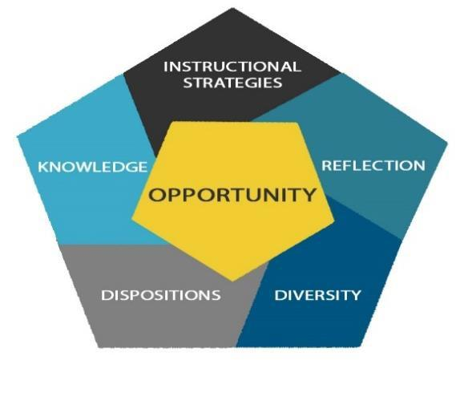

Opportunity
Opportunity is the key theme of the Conceptual Framework of the Education Department. It emphasizes the empowering and transformative role education plays in the lives of individuals and entire communities. The Education Department seeks to prepare reflective educators who are dedicated to teaching and learning, who have an understanding and appreciation of the synthesis of theory and practice, who recognize the value and importance of collaboration and mentoring, and who possess and demonstrate proper ethical and professional dispositions. The ultimate outcome is to prepare educators able to recognize the educational needs of their times and able to respond to them in a meaningful way.
The Conceptual Framework of the Education Department is based upon 5 dimensions:

Knowledge
Knowledge is the assimilation and accommodation of the various areas of study in becoming a teacher and an educated person. To achieve a depth of understanding requires the application of thinking processes such as scientific thinking, critical thinking, creative thinking and other forms of reasoning.

Reflection
Reflection is an integral part of academic and professional growth. Being a reflective thinker implies a willingness to review, reexamine, evaluate and rethink educational concepts, processes, and practices.

Dispositions
Academic and professional attitudes, values, and beliefs are demonstrated through both verbal and non- verbal behaviors as educators interact with students, families, and colleagues. In addition to assessing content knowledge and pedagogical skills of pre-service teachers, the Education Department identifies, evaluates, and develops students' attitudinal behaviors, or dispositions.

Diversity
The Education Department recognizes the importance of designing and implementing curricula that support students’ appreciation of social justice, awareness and acceptance of differences among people based on ethnicity, race, socioeconomic status, gender, exceptionalities, language, religion, sexual orientation, and geographical area.

Instructional Strategies
Instructional strategies emphasized in the Education Department reflect the current art and science of pedagogy. Education Department faculty employ research-based and data-informed practices in varied classroom settings and with diverse student populations. They are intended to facilitate students’ progress and educational success.

Appendix II
Common Core Teaching Standards

Standard # 1 Learner Development (Maine 2012)
The teacher understands how students learn and develop, recognizing that patterns of learning and development vary individually within and across the cognitive, linguistic, social, emotional, and physical areas, and designs and implements developmentally appropriate and challenging learning experiences.

Performance:
1(a) Regularly assesses individual and group performance in order to design and modify instruction to meet learners’ needs in each area of development (cognitive, linguistic, social, emotional, and physical) and scaffolds the next level of development.
1(b) Creates developmentally appropriate instruction that takes into account individual learners’ strengths, interests and needs and that enables each learner to advance and accelerate his/her learning.
1(c) Collaborates with families, communities, colleagues and other professionals to promote learner growth and development.
Essential Knowledge:
1(d) Understands how learning occurs – how learners construct knowledge, acquire skills, and develop disciplined thinking processes – and knows how to use instructional strategies that promote student learning. 1(e) Understands that each learner’s cognitive, linguistic, social, emotional, and physical development influences learning and knows how to make instructional decisions that build on learners’ strengths and needs.
1(f) Identifies readiness for learning, and understands how development in any one area may affect performance in others.
1(g) Understands the role of language and culture in learning and knows how to modify instruction to make language comprehensible and instruction relevant, accessible, and challenging.

Critical Dispositions:
1(h) Respects learner’s differing strengths and needs and is committed to using this information to further each learner’s development.
1(i) Is committed to using learners’ strengths as a basis for growth, and their misconceptions as opportunities for learning.
1(j) Takes responsibility for promoting learner’s growth and development.
1(k) Values the input and contribution of families, colleagues, and other professionals in understanding and supporting each learner’s development.
Standard #2 Learning Differences
The teacher uses understanding of individual differences and diverse cultures and communities to ensure inclusive learning environments that allow each learner to reach his/her full potential.

Performance:
2(a) Designs, adapts, and delivers instruction to address each student’s diverse learning strengths and needs and creates opportunities for students to demonstrate their learning in different ways.
2 (b) Makes appropriate and timely provisions (e.g. pacing for individual rates of growth, task demands, communication, assessment, and response modes) for individual students with particular learning differences or needs.
2 (c) Designs instruction to build on learners’ prior knowledge and experiences, allowing learners to accelerate as they demonstrate their understandings.
2 (d) Brings multiple perspectives to the discussion of content, including attention to learners' personal, family, and community experiences and cultural norms. 2 (e) Incorporates tools of language development into planning and instruction, including strategies for making content accessible to English language learners and for evaluating and supporting their development of English proficiency.
2 (f) Accesses resources, supports, and specialized assistance and services to meet particular learning differences or needs.
Essential Knowledge:
2 (g) Understands and identifies differences in approaches to learning and performance and knows how to design instruction that uses each student's strengths to promote growth.
2 (h) Understands students' exceptional learning needs (both disabilities and giftedness) and knows how to use strategies and resources to serve these needs.
2 (i) Knows about second language acquisition processes and knows how to incorporate instructional strategies and resources to support language acquisition.
2 (j) Understands that learners bring assets for learning based on their individual experiences, abilities, talents, and prior learning, and peer and social group interactions, as well as language, culture, family, and community values.
2 (k) Knows how to access information about the values and norms of diverse cultures and communities and how to incorporate students' experiences, cultures, and community resources into instruction.

Critical Dispositions:
2 (l) Believes that all learners can achieve at high levels and persists in helping each learner reach his/her full potential.
2(m) Respects learners as individuals with differing personal and family backgrounds and various skills, abilities, perspectives, talents, and interests.
2 (n) Makes learners feel valued and helps them learn to value each other.
- (o) Values diverse languages and dialects and seeks to integrate them into his/her instructional practice to engage students in learning.
Standard #3 Learning Environments
The teacher works with learners to create environments that support individual and collaborative learning, encouraging positive social interaction, active engagement in learning, and self motivation.

Performance:
3(a) Collaborates with learners, families, and colleagues to build a safe, positive learning climate of openness, mutual respect, support, and inquiry.
- (b) Develops learning experiences that engage learners in collaborative and self-directed learning and that extend learner interaction with ideas and people locally and globally.
3 (c) Collaborates with learners and colleagues to develop shared values and expectations for respectful interactions, rigorous academic discussions, and individual and group responsibility for quality work. 3 (d) Manages the learning environment to actively and equitably engage learners by organizing, allocating, and coordinating the resources of time, space, and learners’ attention.
3 (e) Uses a variety of methods to engage learners in evaluating the learning environment and collaborates with learners to make appropriate adjustments.
3 (f) Communicates verbally and nonverbally in ways that demonstrate respect for and responsiveness to the cultural backgrounds and differing perspectives learners bring to the learning environment.
3 (g) Promotes responsible learner use of interactive technologies to extend the possibilities for learning locally and globally.
3 (h) Intentionally builds learner capacity to collaborate in face-to-face and virtual environments through applying effective interpersonal communication skills.
Essential Knowledge:
3 (i) Understands the relationship between motivation and engagement and knows how to design learning experiences using strategies that build learner self direction and ownership of learning.
3 (j) Knows how to help learners work productively and cooperatively with each other to achieve learning goals.
3 (k) Knows how to collaborate with learners to establish and monitor elements of a safe and productive learning environment including norms, expectations, routines, and organizational structures. 3 (l) Understands how learner diversity can affect communication and knows how to communicate effectively in differing environments.
3 (m) Knows how to use technologies and how to guide learners to apply them in appropriate, safe, and effective ways.

Critical Dispositions:
3 (n) Is committed to working with learners, colleagues, families, and communities to establish positive and supportive learning environments.
3 (o) Values the role of learners in promoting each other’s learning and recognizes the importance of peer relationships in establishing a climate of learning.
3 (p) Is committed to supporting learners as they participate in decision making, engage in exploration and invention, work collaboratively and independently, and engage in purposeful learning.
3 (q) Seeks to foster respectful communication among all members of the learning community.
- (r) Is a thoughtful and responsive listener and observer.
Standard #4 Content Knowledge
The teacher understands the central concepts, tools of inquiry, and structures of the discipline(s) he or she teaches and creates learning experiences that make these aspects of the discipline accessible and meaningful for learners.

Performance:
- (a) Effectively uses multiple representations and explanations that capture key ideas in the discipline, guide learners through learning progressions, and promote each learner’s achievement of content standards.
4 (b) Engages students in learning experiences in the discipline(s) that encourage learners to understand, question, and analyze ideas from diverse perspectives so that they master the content.
4 (c) Engages students in applying methods of inquiry and standards of evidence used in the discipline.
4 (d) Stimulates student reflection on prior content knowledge, links new concepts to familiar concepts, and makes connections to learners' experiences.
4 (e) Recognizes learner misconceptions in a discipline that interfere with learning and, creates experiences to build accurate conceptual understanding.
4 (f) Evaluates and modifies instructional resources and curriculum materials for their comprehensiveness, accuracy for representing particular concepts in the discipline, and appropriateness for his/her learners.
4 (g) Uses supplementary resources and technologies effectively to ensure accessibility and relevance to all learners.
4 (h) Creates opportunities for students to learn, practice, and master academic language in their content.
4 (i) Accesses school and/or district-based resources to evaluate the learner’s content knowledge in their primary language.

Essential Knowledge:
4 (j) Understands major concepts, assumptions, debates, processes of inquiry, and ways of knowing that are central to the discipline(s) s/he teaches.
4 (k) Understands common misconceptions in learning the discipline and how to guide learners to accurate conceptual understanding.
4 (l) Knows and uses the academic language of the discipline and knows how to make it accessible to learners.
4 (m) Knows how to integrate culturally relevant content to build on learners' background knowledge. 4 (n) Has a deep knowledge of student content
standards and learning progressions in the discipline(s) s/he teaches.

Critical Dispositions:
4 (o) Realizes that content knowledge is not a fixed body of facts but is complex, culturally situated, and ever evolving. S/he keeps abreast of new ideas and understandings in the field.
4 (p) Appreciates multiple perspectives within the discipline and facilitates learners’ critical analysis of these perspectives.
4 (q) Recognizes the potential bias in his/her representation of the discipline and seeks to appropriately address problems of bias
- (r) Is committed to work toward each learner’s mastery of disciplinary content and skills.
Standard #5 Innovative Applications of Content The teacher understands how to connect concepts and use differing perspectives to engage learners in critical/creative thinking and collaborative problem solving related to authentic local and global issues.

Performance:
- (a) Develops and implements projects that guide learners in analyzing the complexities of an issue or question using perspectives from varied disciplines and cross-disciplinary skills (e.g., a water quality study that draws upon biology and chemistry to look at factual information and social studies to examine policy implications).
5 (b) Engages learners in applying content knowledge to real world problems through the lens of interdisciplinary themes (e.g., financial literacy, environmental literacy). 5 (c) Facilitates learners’ use of content tools and resources to maximize content learning in varied contexts.
5 (d) Engages learners in questioning and challenging assumptions and approaches in order to foster innovation and problem solving in local and global contexts.
5 (e) Develops learners' communication skills in disciplinary and interdisciplinary contexts by creating meaningful opportunities to employ a variety of forms of communication that address varied audiences and purposes.
5 (f) Engages learners in generating and evaluating new ideas and novel approaches, seeking inventive solutions to problems, and developing original work.
5 (g) Facilitates learners’ ability to develop diverse social and cultural perspectives that expand their understanding of local and global issues and create novel approaches to solving problems.
5 (h) Develops and implements supports for learner literacy development across content areas.
Essential Knowledge:
5 (i) Understands the ways of knowing in his/her discipline, how it relates to other disciplinary approaches to inquiry, and the strengths and limitations of each approach in addressing problems, issues and concerns.
5 (j) Understands how current interdisciplinary themes (e.g., civic literacy, health literacy, global awareness) connect to the core subjects and knows how to weave those themes into meaningful learning experiences.
5 (k) Understands the demands of accessing and managing information as well as how to evaluate issues of ethics and quality related to information and its use. 5 (l) Understands how to use digital and interactive technologies for efficiently and effectively achieving specific learning goals.
5 (m) Understands critical thinking processes and knows how to help learners develop high level questioning skills to promote their independent learning.
5 (n) Understands communication modes and skills as vehicles for learning (e.g., information gathering and processing) across disciplines as well as vehicles for expressing learning.
5 (o) Understands creative thinking processes and how to engage learners in producing original work.
5 (p) Knows where and how to access resources to build global awareness and understanding, and how to integrate them into the curriculum.

Critical Dispositions:
5 (q) Is constantly exploring how to use disciplinary knowledge as a lens to address local and global issues.
5 (r) Values knowledge outside his/her own content area and how such knowledge enhances student learning.
- (s) Values flexible learning environments that encourage learner exploration, discovery and expression across content areas.

Standard #6 Assessment
The teacher understands and uses multiple methods of assessment to engage learners in their own growth, to document learner progress, and to guide the teacher’s on-going planning and instruction.

Performance:
- (a) Balances the use of formative and summative assessment as appropriate to support, verify, and document learning.
6 (b) Designs assessments that match learning objectives with assessment methods and minimizes sources of bias that can distort assessment results. 6 (c) Works independently and collaboratively to
examine test and other performance data to understand each learner’s progress and to guide planning.
6 (d) Engages learners in understanding and identifying quality work and provides them with effective descriptive feedback to guide their progress toward that work.
6 (e) Engages learners in multiple ways of demonstrating knowledge and skill as part of the assessment process.
6 (f) Models and structures processes that guide learners in examining their own thinking and learning as well as the performance of others.
6 (g) Effectively uses multiple and appropriate types of assessment data to identify each student’s learning needs and to develop differentiated learning experiences.
6 (h) Prepares all learners for the demands of particular assessment formats and makes appropriate accommodations in assessments or testing conditions, especially for learners with disabilities and language learning needs.
6 (i) Continually seeks appropriate ways to employ technology to support assessment practice both to engage learners more fully and to assess and address learner needs.
Essential Knowledge:
6 (j) Understands the differences between formative and summative applications of assessment and knows how and when to use each.
6 (k) Understands the range of types and multiple purposes of assessment and how to design, adapt, or select appropriate assessments to address specific learning goals and individual differences, and to minimize sources of bias.
6 (l) Knows how to analyze assessment data to understand patterns and gaps in learning, to guide planning and instruction, and to provide meaningful feedback to all learners.
6 (m) Knows when and how to engage learners in analyzing their own assessment results and in helping to set goals for their own learning.
6 (n) Understands the positive impact of effective descriptive feedback for learners and knows a variety of strategies for communicating this feedback.
6 (o) Knows when and how to evaluate and report learner progress against standards.
6 (p) Understands how to prepare learners for assessments and how to make accommodations in assessments and testing conditions, especially for learners with disabilities and language learning needs.

Critical Dispositions:
6 (q) Is committed to engaging learners actively in assessment processes and to developing each learner’s capacity to review and communicate about their own progress and learning.
6 (r) Takes responsibility for aligning instruction and assessment with learning goals.
6 (s) Is committed to providing timely and effective descriptive feedback to learners on their progress.
6 (t) Is committed to using multiple types of assessment processes to support, verify, and document learning.
- (u) Is committed to making accommodations in assessments and testing conditions, especially for learners with disabilities and language learning needs. 6 (v) Is committed to the ethical use of various assessments and assessment data to identify learner strengths and needs to promote learner growth.
Standard #7 Planning for Instruction
The teacher draws upon knowledge of content areas, cross-disciplinary skills, learners, the community, and pedagogy to plan instruction that supports every student in meeting rigorous learning goals.

Performance:
- (a) Individually and collaboratively selects and creates learning experiences that are appropriate for curriculum goals and content standards, and are relevant to learners.
7 (b) Plans how to achieve student learning goals, choosing appropriate strategies and accommodations, resources and materials to differentiate instruction for individuals and groups of learners.
7 (c) Develops appropriate sequencing of learning experiences and provides multiple ways to demonstrate knowledge and skill.
7 (d) Plans for instruction based on formative and summative assessment data, prior learner knowledge, and learner interest.
7 (e) Plans collaboratively with professionals who have specialized expertise (e.g., special educators, related service providers, language learning specialists, librarians, media specialists) to design and jointly deliver as appropriate learning experiences to meet unique learning needs.
7 (f) Evaluates plans in relation to short-and-long- range goals and systematically adjusts plans to meet each student’s learning needs and enhance learning.
Essential Knowledge:
7 (g) Understands content and content standards and how these are organized in curriculum.
7 (h) Understands how integrating cross-disciplinary skills in instruction engage learners purposefully in applying content knowledge.
7 (i) Understands learning theory, human development, cultural diversity, and individual differences and how these impact on-going planning.
7 (j) Understands the strengths and needs of individual learners and how to plan instruction that is responsive to these strengths and needs.
7 (k) Knows a range of evidence-based instructional strategies, resources, and technological tools and how to use them effectively to plan instruction that meets diverse learning needs.
7 (l) Knows when and how to adjust plans based on assessment information and learner responses.
7 (m) Knows when and how to access resources and collaborate with others to support student learning (e.g., special educators, related service specialists, language learner specialists, media specialists, community organizations).

Critical Dispositions:
7 (n) Respects students’ diverse strengths and needs and is committed to using this information to plan effective instruction.
7 (o) Values planning as a collegial activity that takes into consideration the input of learners, colleagues, families, and the larger community.
7 (p) Takes professional responsibility to use short- and-long-term planning as a means of assuring student learning.
- (q) Believes that plans must always be open to adjustment and revision based on learner needs and changing circumstances.
Standard #8 Instructional Strategies
The teacher understands and uses a variety of instructional strategies to encourage learners to develop deep understanding of content areas and their connections, and to build skills to access and appropriately apply information.

Performance:
- (a) Uses appropriate strategies and resources to adapt instruction to the needs of individuals and groups of learners.
8 (b) Continuously monitors student learning, engages learners in assessing their progress, and adjusts instruction in response to student learning needs.
8 (c) Collaborates with learners to design and implement relevant learning experiences, identify their strengths, and access family and community resources to develop their areas of interest.
8 (d) Varies his or her role in the instructional process (e.g., instructor, facilitator, coach, audience) in relation to the content and purposes of instruction and the needs of learners.
8 (e) Provides multiple models and representations of concepts and skills with opportunities for learners to demonstrate their knowledge through a variety of products and performances.
8 (f) Engages all learners in developing higher order questioning skills and meta-cognitive processes.
8 (g) Engages students in using a range of learning skills and technology tools to access, interpret, evaluate, and apply information.
8 (h) Uses a variety of instructional strategies to support and expand learners' communication through speaking, listening, reading, writing, and other modes. 8 (i) Asks questions to stimulate discussion that serves different purposes, (e.g., probing for learner understanding, helping students articulate their ideas and thinking processes, promoting risk-taking and problem-solving, facilitating factual recall, stimulating curiosity, and helping learners to question).
Essential Knowledge:
8 (j) Understands the cognitive processes associated with various kinds of learning (e.g., critical and creative thinking, problem framing and problem solving, invention, memorization and recall) and how these processes can be stimulated.
8 (k) Knows how to apply a range of developmentally, culturally, and linguistically appropriate instructional strategies, to achieve learning goals.
8 (l) Knows when and how to use appropriate strategies to differentiate instruction and engage all learners in complex thinking and meaningful tasks. 8 (m) Understands how multiple forms of communication (oral, written, nonverbal, digital,
visual) convey ideas, foster self expression, and build relationships.
8 (n) Knows how to use a wide variety of resources, including human and technological, to engage student learning.
8 (o) Understands how content and skill development can be supported by media and technology and knows how to evaluate these resources for quality, accuracy and effectiveness.

Critical Dispositions:
8 (p) Is committed to deepening awareness and understanding the strengths and needs of diverse learners when planning and adjusting instruction. 8 (q) Values the variety of ways that people
communicate and encourages learners to develop and use multiple forms of communication.
8 (r) Is committed to exploring how the use of new and emerging technologies can support and promote student learning.
- (s) Values flexibility and reciprocity in the teaching process as necessary for adapting instruction to student responses, ideas, and needs.
Standard #9
Reflection and Continuous Growth
The teacher is a reflective practitioner who uses evidence to continually evaluate his/her practice, particularly the effects of his/her choices and actions on others (students, families, and other professionals in the learning community), and adapts practice to meet the needs of each learner.

Performance:
- (a) Engages in ongoing learning opportunities to develop knowledge and skills in order to provide all learners with engaging curriculum and learning experiences based on local and state standards.
9 (b) Engages in meaningful and appropriate professional learning experiences aligned with his/her own needs and the needs of the learners, school, and system.
9 (c) Independently, and in collaboration with colleagues, the teacher uses a variety of data (e.g., systematic observation, information about learners, research) to evaluate the outcomes of teaching and learning and to adapt planning and practice.
9 (d) Actively seeks professional, community, and technological resources, within and outside the school, as supports for analysis, reflection, and problem- solving.
9 (e) Reflects on his/her personal biases and accesses resources to deepen his/her own understanding of cultural, ethnic, gender, and learning differences to build stronger relationships and create more relevant learning experiences.
9 (f) Advocates, models, and teaches safe, legal, and ethical use of information and technology including appropriate documentation of sources and respect for others in the use of social media.
Essential Knowledge:
9 (g) Understands and knows how to use a variety of self-assessment and problem-solving strategies to analyze and reflect on his/her practice and to plan for adaptations/adjustments.
9 (h) Understands and knows how to use learner data to analyze practice and differentiate instruction accordingly.
9 (i) Understands how personal identity, worldview, and prior experience affect perception and expectations, and recognizes how they may bias behaviors and interactions with others.
9 (j) Understands laws related to learners’ rights and teacher responsibilities (e.g., for educational equity, appropriate education for learners with disabilities, confidentiality, privacy, appropriate treatment of learners, reporting in situations related to possible child abuse).
9 (k) Knows how to build and implement a plan for professional growth directly aligned with his/her needs as a growing professional using feedback from teacher evaluations and observations, data on learner performance, and school- and system-wide priorities.

Critical Dispositions:
9 (l) Takes responsibility for student learning and uses ongoing analysis and reflection to improve planning and practice.
9 (m) Is committed to deepening understanding of his/her own frames of reference (e.g., culture, gender, language, abilities, ways of knowing), the potential biases in these frames, and their impact on expectations for relationships with learners and their families.
9 (n) Sees him/herself as a learner, continuously seeking opportunities to draw upon current education policy and research as sources of analysis and reflection to improve practice.
- (o) Understands the expectations of the profession including codes of ethics, professional standards of practice, and relevant law and policy.Taken from Chapter 114 of the Rule Chapters for the Maine Department of Education: http://www.maine.gov/sos/cec/rules/05/chaps05. htm

Standard #10 Collaboration
The teacher seeks appropriate leadership roles and opportunities to take responsibility for student learning, to collaborate with learners, families, colleagues, other school professionals, and community members to ensure learner growth, and to advance the profession.

Performance:
- (a) Takes an active role on the instructional team, giving and receiving feedback on practice, examining learner work, analyzing data from multiple sources, and sharing responsibility for decision making and accountability for each student’s learning.
10 (b) Works with other school professionals to plan and jointly facilitate learning on how to meet diverse needs of learners.
10 (c) Engages collaboratively in the school- wide effort to build a shared vision and supportive culture, identify common goals, and monitor and evaluate progress toward those goals.
10 (d) Works collaboratively with learners and their families to establish mutual expectations and ongoing communication to support learner development and achievement.
10 (e) Works with school colleagues to build ongoing connections with community resources to enhance student learning and well being.
10 (f) Engages in professional learning, contributes to the knowledge and skill of others, and works collaboratively to advance professional practice.
10 (g) Uses technological tools and a variety of communication strategies to build local and global learning communities that engage learners, families, and colleagues.
10 (h) Uses and generates meaningful research on education issues and policies.
10 (i,j) Seeks appropriate opportunities to model effective practice for colleagues, to lead professional learning activities, and to serve in other leadership roles.
10 (k) Takes on leadership roles at the school, district, state, and/or national level and
advocates for learners, the school, the community, and the profession.

Essential Knowledge:
10 (l) Understands schools as organizations within a historical, cultural, political, and social context and knows how to work with others across the system to support learners.
10 (m) Understands that alignment of family, school, and community spheres of influence enhances student learning and that discontinuity in these spheres of influence interferes with learning.
10 (n) Knows how to work with other adults and has developed skills in collaborative interaction appropriate for both face-to-face and virtual contexts.
- (o) Knows how to contribute to a common culture that supports high expectations for student learning.

Critical Dispositions:
10 (p) Actively shares responsibility for shaping and supporting the mission of his/her school as one of advocacy for learners and accountability for their success.
10 (q) Respects families’ beliefs, norms, and expectations and seeks to work collaboratively with learners and families in setting and meeting challenging goals.
10 (r) Takes initiative to grow and develop with colleagues through interactions that enhance practice and support student learning.
10 (s) Takes responsibility for contributing to and advancing the profession.
10 (t) Embraces the challenge of continuous improvement and change.

Standard #11 Technology Standards for Teachers – (NETS-T*): Effective teachers model and apply the National Educational Technology Standards for Students (NETS-S**) as they design, implement, and assess learning experiences to engage students and improve learning; enrich professional practice; and provide positive models for students, colleagues, and the community. Please see the following ISTE Standards Teachers and ISTE Standards Students pages.
*Now known as ISTE Standards Teachers
**Now known as ISTE Standards Students
Rev. 8/14

Appendix III
Two Semester Intern Option

The two semester intern option combines the Practicum in Education course (EDU 395) and Student Teaching (EDU 495) experiences in a single classroom setting. While the traditional pathway can provide different perspectives from a variety of mentors, classroom settings and grade level skills and curriculum, the purpose of the internship is to provide the student with an experience similar to that of a first-year teacher. One significant advantage to this option is being able to follow one group of pupils through most of a school year as they develop skills and progress through the curriculum for that grade level.

Intern candidates will submit an application to the Coordinator of Student Teaching and Field Experiences early in the spring semester prior to the internship year. They will have the experience of a formal interview with school administration and the prospective cooperating teacher, and possibly other members of the district search committee to determine their suitability for the intern position being considered. Based on this interview, the host school will determine whether or not a student is accepted as an intern in that setting.

The intern experience begins several days before the official opening of school in the fall semester. The student will work with the cooperating teacher to help in setting up the classroom for the opening day. During this time there are many opportunities to learn about things such as long-range planning, setting up lesson plan books and grade books (or other formats for tracking plans and grades), orientation to the school and the resources available, introduction to school staff and other teachers, etc.

The student will attend the first full week of public school classes in the host classroom. This experience will provide insights into what the teacher does to become acquainted with his/her new pupils and to establish the tone and parameters for the learning environment for the coming year. If there are schedule conflicts with university classes, the student must make prior arrangements with instructors to arrange for excused absences and to obtain assignments or materials given out during this time frame.

Following the opening week, students will participate in the public school classroom one full day per week for the remainder of the fall semester, depending on their university class schedule. Though a full day is preferred, one morning session and one afternoon session on a different day will enable the student to see routines for an entire school day. This experience will serve as the basis for observation and reflection assignments for the Practicum in Education course. Beyond this course requirement, a student may participate in the public school classroom in whatever ways deemed appropriate by the cooperating teacher. The Suggested Year Plan for Elementary (or Secondary) Interns included in this Appendix can serve as a guide, though is by no means exhaustive in its suggestions.

The student will remain with the same cooperating teacher for the duration of the Student Teaching (EDU
495) semester in the spring. Based on the fall semester experience in this classroom, it is expected that the student will assume teaching responsibilities early on and will explore a variety of teaching experiences guided by the cooperating teacher. These experiences can include, but are not limited to, small group work, full class teaching, team teaching, cooperative learning activities, etc. The options are limited only by the creativity and joint planning of the student and cooperating teacher.

The two semester internship is a robust opportunity that is a value-added experience going beyond what can be accomplished following the more traditional pathway. The end result is a teacher candidate who is more fully prepared for the realities of a first-year teaching experience.

Suggested Year Plan for Elementary Interns

August | September | October | November | December
Assist with Classroom set up.  Get oriented to building, learn the basics (emergency procedures, record keeping etc.)  Attend and participate in workshop days.  Attend and participate in all aspects of first week of school. | Become familiar with benchmark assessments, IEPs  Do some correcting of papers  Attend and participate in evening Open House  Attend and participate in Teacher Workshop Day (CACE)  Relationship building  Read alouds  Help with student transitions  Develop an understanding of classroom management  Participate in field trips  Learn about duties  Learn how to take attendance  Assist with individuals and small groups  Experience working with students with disabilities | Continue developing an understanding of procedures and routines  Participate in any standardized testing  Be introduced to curriculum | Participate in Parent Teacher Conferences  Continue to learn about classroom management techniques  Begin to develop some understanding of grades, grading and keeping a plan book | Begin learning about guided, shared, and independent reading  Dealing with holiday stress  Classroom management continued  Begin assuming teaching responsibilities as appropriate

January | February | March | April | May
Attending full weeks  Beginning of transfer of responsibility (bell work, a content area, a particular day of the week)  Beginning to learn about guided, shared and independent reading  Help administer mid-year assessments  Participate in PLC and/or professional development opportunities (PD)  Co-teaching  Attend staff meetings and other school related meetings  Utilize a formal lesson plan template for lessons  During the next 3 months, the intern will develop and implement a unit of study | Continue transfer of responsibility  Analyzing data from mid-year assessments  Continue learning about guided, shared and independent reading  Begin to participate in guided reading groups  Participate in PLC or PD  Continue co- teaching  Reading and discussing articles about best practices in teaching | Minimum two weeks of solo teaching  Create a bulletin board or anchor charts or website  Observation by principal of intern (by request)  Co-teaching, slow release of responsibilities  Participate in PLC or PD | Co-teaching, slow release of responsibilities  Observe other teachers  Do a mock interview with the principal (by request)  Follow up debriefing of interview process  Participate in PLC or PD | End of placement as designated on placement sheet (adjust for storm cancellations or absences)

Suggested Year Plan for Secondary Interns

August | September | October | November | December
Assist with Classroom set up  Get oriented to building, learn the basics (emergency procedures, record keeping etc.)  Attend and participate in workshop days.  Attend and participate in all aspects of first week of school. | Become familiar with benchmark assessments, IEPs  Do some correcting of papers  Attend and participate in evening Open House  Attend and participate in Teacher Workshop Day (CACE)  Relationship building  Develop an understanding of classroom management  Participate in field trips  Learn about duties  Learn how to take attendance  Assist with individuals and small groups  Experience working with students with disabilities | Continue developing an understanding of procedures and routines  Participate in any standardized testing  Be introduced to curriculum | Participate in Parent Teacher Conferences  Continue to learn about classroom management techniques  Begin to develop some understanding of grades, grading and keeping a plan book | Classroom management continued  Begin assuming teaching responsibilities as appropriate

January | February | March | April | May
Attending full weeks  Beginning of transfer of responsibility (bell work, a designated class, a particular day of the week)  Explore writing across the curriculum  Explore variety of lesson delivery  Help administer mid-year assessments  Participate in PLC's and/or professional development (PD) opportunities  Co-teaching  Attend staff meetings and other school related meetings  Utilize a formal lesson plan template for lessons  During the next 3 months, the intern will develop and implement a unit of study | Continue transfer of responsibility  Analyzing data from mid-year assessments  Continue learning about guided, shared and independent reading  Participate in PLC or PD  Continue co- teaching  Reading and discussing articles about best practices in teaching | Minimum two weeks of solo teaching  Create a bulletin board or anchor charts or website  Observation by principal of intern (by request)  Co-teaching, slow release of responsibilities  Participate in PLC or PD | Co-teaching, slow release of responsibilities  Observe other teachers  Do a mock interview with the principal (by request)  Follow up debriefing of interview process  Participate in PLC or PD | End of placement as designated on placement sheet (adjust for storm cancellations or absences)

Appendix IV

Select the Tk20 Icon
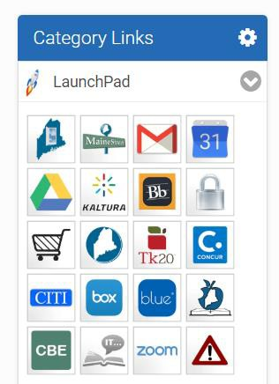

You will see: (Please do not use the Artifacts Tab) you need to select the Field Experience

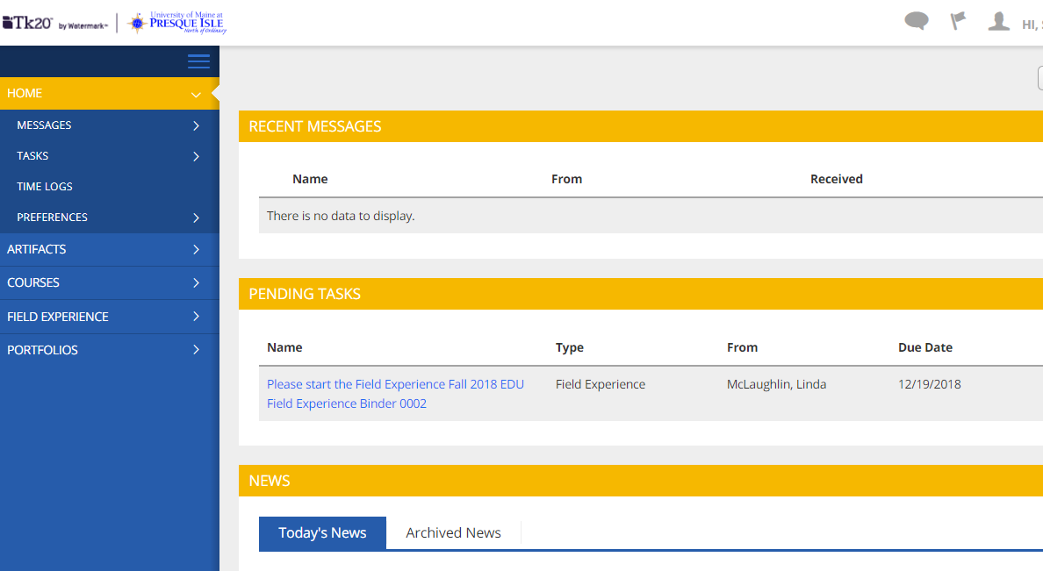
Tab

From here you can click on your pending task hyperlink
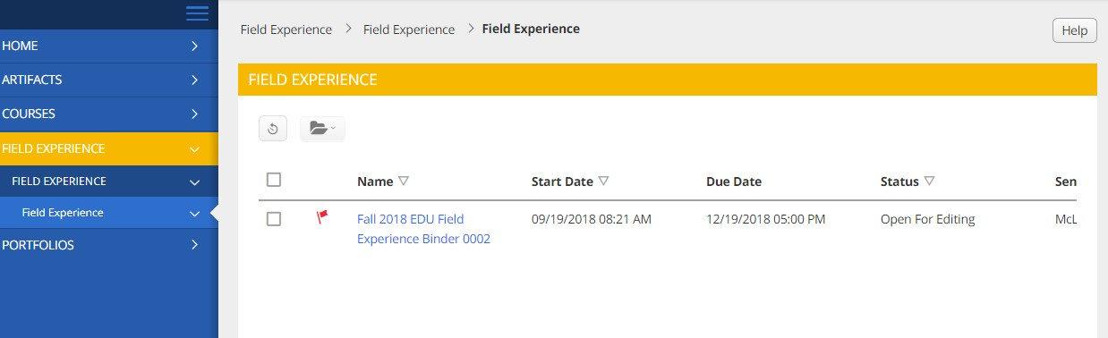
or select Field Experience (see below)

You can select the blue Hyperlink
It will bring you to this screen: Your placement information will be in the blue shaded area.
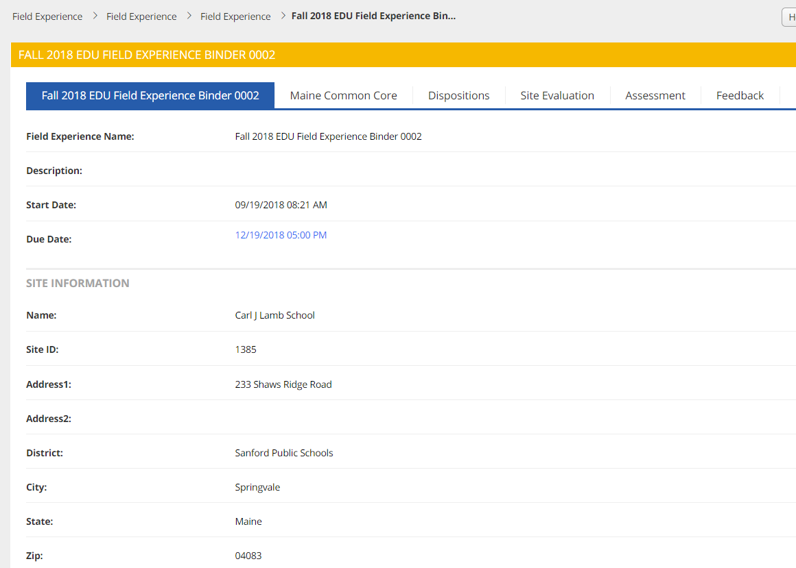

Select Maine Common Core Tab
You will see this: To complete each click on the Select button. To edit a completed from select the hyperlink. You can add, save and update but do not submit until all four sections have been completed and you have completed all of the work in the binder.
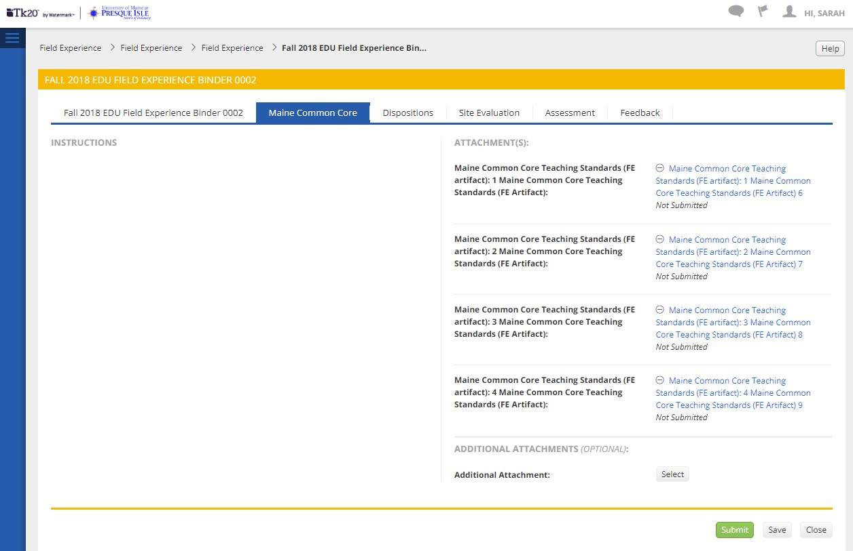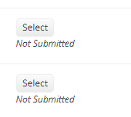

This will bring you to a rubric where you will complete the 11 standards. You will put artifacts after each section such as The Learner and Learning 1-3 the artifacts will follow that rubric area and so forth. Select add. If you need to update a section you have completed you will select the hyperlink and make changes then select Update. You can add, save and update at any time prior to submitting your field experience binder. Please do not submit your binder until all areas are completed. Once you have completed your binder at the end of the semester you can submit.
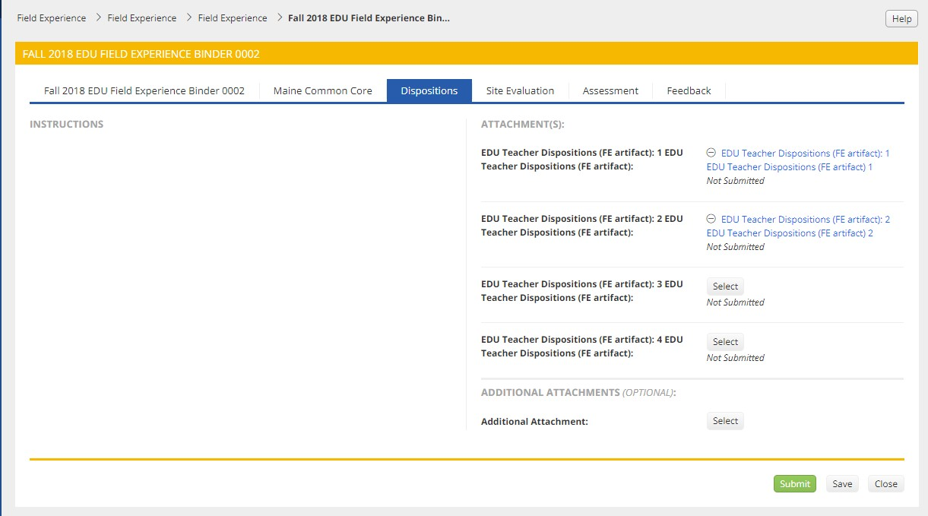
You will also complete the dispositions tab: Then click on select (the blue hyperlink will appear once you added information in that section).

You will also complete the Site Evaluation tab for each Cooperating Teacher and your University Supervisor at the end of the semester. As with the other forms click the select button to complete the form. A blue hyperlink will appear once you save it and you will be able to update it as needed until you submit your Field Experience Binder at the end of the Semester.
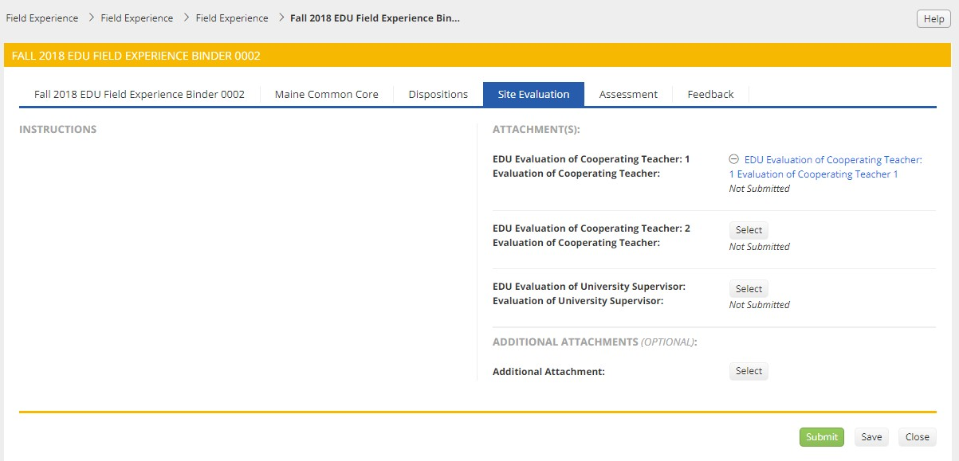
Once you submit you are not able to make changes unless your Instructor for Student Teaching reopens the binder for you.

