

**BACHELOR OF SOCIAL WORK PROGRAM**

##### FIELD EDUCATION MANUAL

**2023-2024**

Bachelor of Social Work Faculty 1

Introduction 2

Mission of Bachelor of Social Work Program 3

BSW Goals 3

The Generalist Model of Social Work Practice 4

Field Education Learning Outcomes 6

Field Education Policies 7

Requirements for International Student Field placements 8

Field Education Assignments 9

Tk20 Time Log 10

Fall Semester Papers 11

Student Assessment and Learning Plan 11

Spring Semester Papers 20

Revised Student Assessment and Learning Plan 20

Field Education Evaluation 20

Senior BSW Field Evaluation (FE Artifact) 22

Policy for Field Practicum Site Selection 33

Memorandum Of Agreement: BSW Program Field Placement 35

Supervision 37

Confidentiality 38

Field Setting Evaluation 39

Classroom Conduct and Comportment 40

Insurance Information 42

Notice Of Risks To Student Participants 43

Background Check Policy 44

Field Education Seminar 45

Appendix A: NASW Code of Ethics 46

Appendix B: Council on Social Work Education Educational Policy And Accreditation Standards (EPAS) 47

Appendix C: Field Education Selection Process 48

**University of Maine Presque Isle**

# Bachelor of Social Work Faculty

Beverly Wagner, EdD, MSW, LCSW

Director of BSW Program/ Assistant Professor

South Hall 312

207-768-9427

[beverly.wagner@maine.edu](mailto:beverly.wagner@maine.edu)

Shawna Traugh, DSW, MSW, LCSW

Director of Field Education/Assistant Professor

South Hall 311

207-768-9422

[shawna.traugh@maine.edu](mailto:shawna.traugh@maine.edu)

# Introduction

The Field Practicum is designed to enhance the students’ ability to function as a Professional Social Worker and to build upon the students’ knowledge, skills, values, and personal qualities. The placement provides an opportunity to use information gained from the academic courses together with personal experience and apply skills in a community-based delivery system. It is a time for ascertaining a student’s motivation, aptitude, and emotional readiness for a career in social work.

The Practicum is taken for two semesters for a minimum total of 500 hours for the academic year. It is expected the student will provide 16 – 18 hours per week of Practicum time at a designated agency- SWK 494 A & B, 6 credits. The students will participate in a Field Practicum seminar- SWK 492A & SWK 492B on campus each semester for 3 hours per week. The seminar and Field Practicum will total nine (9) credits each semester. The Field Practicum is taken concurrently with Social Work Practice courses (SWK 400, Social Work Practice II in the fall, and SWK 405, Social Work Practice III in the spring). Therefore, an incomplete or failure in SWK 400 or SWK 492A may hinder starting SWK 405 or SWK 492B and the second semester of the Field Practicum -SWK 494B.

Students enter the field practicum sequences after acceptance to the BSW Program and completion of SWK 315 – Social Work Practice I and SWK 396B – Junior Field II.

# Mission of Bachelor of Social Work Program

**MISSION**

In conjunction with the mission statement of the University of Maine Presque Isle the Bachelor of Social Work Program is committed to preparing students for entry-level professional generalist practice. Global consciousness will be emphasized as the means to understand and practice social work ethics, values, and skills. The program is committed to promoting the well-being, growth and empowerment of all individuals, families, groups, communities and organizational systems.

### BSW Goals

1. Plan and work with client systems of all sizes using culturally responsive, generalist social work methodology.
2. Apply a practice framework that demonstrates social, racial, economic, and environmental justice to advance human rights for all system levels.
3. Utilize global critical thinking and self-awareness.
4. Engage in research informed practice and practice informed research and policy practice.
5. Effect culturally responsive, inclusive change through practice in rural and global communities.

# The Generalist Model of Social Work Practice

Beginning in the late 1800’s the United States saw the growth of two approaches to helping people: the Settlement House movement and the Charity Organization Societies. Both approaches were developed out of concern about ‘what to do’ with the massive influx of immigrants to North America from all over the world. Settlement houses operated on the belief that creating systems of support in communities and organizations was the best way to helping immigrant groups successfully transition to American society. Much of the work done in the settlement houses was later incorporated into state and federal social welfare policies.

During this same era, Charity Organization Societies were created in many urban settings by concerned citizens who wished to help individuals and families. These groups consisted of wealthy people who were primarily compelled by religious tenets to help needy people. The underlying function of the groups was to try and reduce the crime, disease, and moral degradation that came to define immigrant groups in urban settings. This group employed ‘friendly visitors’ who were usually upper middle class, young, single women. The visitors went to the city’s immigrant enclaves and were charged with determining what was most needed by the people in that setting. Reports to the society would then lead to committee decisions about what, if any of the needs would be addressed. Most of the time, the society would arrange for things such as blankets or food and did not believe in providing money.

These two ways of helping evolved into the current concept of social work. Undergraduate social work education focuses on preparing people to practice beginning generalist social work practice. Kirst-Ashman (2010) defines generalist social work practice as:

The application of an eclectic knowledge base, professional values, and a wide range of skill to target any size system for change within the context of four primary processes. First, generalist practice emphasizes client empowerment. Second, it involves working effectively within an organizational structure and doing so under supervision. Third, it requires the assumption of a wide range of professional roles. Fourth, it involves the application of critical thinking skills to the planned change (intervention) process. (p. 27, Social Work and Social Welfare; Critical Thinking Perspectives)

Social workers educated as generalists possess a knowledge, value and skill base that is readily transferable among diverse contexts, locations, and problem situations. Generalist practice incorporates skills to work within the five major systems in our society: individuals, families, groups, organizations, and communities. The generalist repertoire also includes skills applicable to the tasks of lifelong learning and to adaptation of the generalist foundation to specialized situations and contexts.

The University of Maine at Presque Isle Bachelor of Social Work program is anchored in the doctrine of the generalist model. Generalist social work education enhances the effectiveness of graduates in addressing and alleviating the varied social problems of our region. The UMPI BSW program resides in a geographically and socially isolated area. The program stresses that by starting where the client is at and utilizing their own strengths empowers people to move toward positive change. The economic base for rural Maine is driven by either global industry such as tourism and lumbering or self-employment. Therefore, service delivery is most often organized through not-for-profit agencies and organizations. Social workers are the backbone to that workforce. The rural social service delivery systems of Maine need practitioners who can competently fulfill a variety of practice roles, e.g., broker, advocate, administrator, case manager, networker, community organizer, group facilitator, change agent. Lastly, the ability to ask the right questions, determine the best means of addressing issues, and then implementing the strategies to affect change describes the critical thinking aspect of this BSW program.

# Field Education Learning Outcomes

The Educational Policy and Accreditation Standards (EPAS, 2022) written by the Council on Social Work Education outlines a set of core competencies. Competency-based education is an outcome performance approach to curriculum design. Each competency describes knowledge, values, skills, and cognitive and affective processes that comprise the competency at the generalist level of practice, followed by a set of behaviors that integrate these components. The goal of the outcome approach is to demonstrate the integration and application of the competencies in practice with individuals, families, groups, organizations, and communities. The nine core competencies are listed below:

1. Demonstrate Ethical and Professional Behavior.
2. Advance Human Rights and Social, Racial, Economic and Environmental Justice.
3. Engage Anti-Racism, Diversity, Equity, and Inclusion (ADEI) in Practice.
4. Engage in Practice-Informed Research and Research-Informed Practice.
5. Engage in Policy Practice.
6. Engage with Individuals, Families, Groups, Organizations, and Communities.
7. Assess Individuals, Families, Groups, Organizations, and Communities.
8. Intervene with Individuals, Families, Groups, Organizations, and Communities.
9. Evaluate Practice with Individuals, Families, Groups, Organizations, and Communities.

# Field Education Policies

1. All students in the Field Education Program will adhere to the UMPI BSW Program standards and the NASW Code of Ethics.
2. Students will complete a current background check from their state or province at their own expense and a copy given to the Field Director before entering Senior Field I.
3. The copy of the background check will be kept in the student’s academic file until completion of the BSW degree or a change of major, at which time the background check will be shredded.
4. If information is revealed on the background check which will impede completing the field work or obtaining a social work license, the student will be advised and assisted with other educational options.
5. Students are encouraged to purchase a student malpractice insurance policy and give a copy of the effective policy to the Field Director. The copy will be kept in the student’s academic file.
6. If a practicum is revoked by the agency or Field Director due to agency changes, the Field Director will work with the student to obtain field work to complete the field education requirements.
7. If a practicum is terminated due to student performance, conduct or comportment, the student will meet with the BSW faculty to determine the student’s future in the program. Each case will be handled individually but will follow all University policies.
8. Life experience is not accepted as a substitute for field work.
9. In recognition of the financial difficulties that students may encounter, the UMPI Social Work program will consider paid placements when possible. Student assignments and tasks may qualify as field hours when directly related to the CSWE competencies. A paid placement may be structured so that the student is receiving a stipend or employment salary. Paid placements must be approved by the Field Director.

# Requirements for International Student Field placements

International students can complete the BSW field experiences in Maine or

Canada. There are extra forms to be completed for Homeland Security.

Maine Placement:

If the international student is completing a field placement in Maine,

whether the optional Junior field placement or the Senior placement, a Curricular Practical Training (CPT) form must be completed before the beginning of semester and the date specified by the field director, and submitted to the DHS representative before the placement is started. <https://www.umpi.edu/admissions/international-students/>

Canadian Placement:

If the international student is completing a field placement in Canada,

whether the optional Junior field placement or the Senior placement, a letter

from the HR or Director of the organization stating whether the organization has a

US tax ID number needs to be on file with the DHS representative.

# Field Education Assignments

**PRACTICUM LOG**

The log is a format in which the students can communicate with the Field Director and receive feedback about their placement experience. It is hoped that it will become a learning tool through which the students will learn to analyze their own experience, a necessary skill for social work practice.

The log is available on Tk20. The student completes the time log each week with a narrative as to what the student is learning and experiencing.

The log is then submitted to the field instructor for approval. The field instructor will receive an email from Tk20 to approve the student log form each week.

The Tk20 software will maintain a calculation and running balance of the student’s field hours.

1. Use Tk20 for the log.
2. The log will not be graded. However, failure to write complete and adequate logs regularly, and to hand them in on time will be seen as an indication of lack of interest in the learning experience and will be reflected in the final grade for the Field Practicum.
3. Material related to clientele should be de-identified so confidentiality is maintained.
4. Summarize all major client contacts and/or agency activities for each day. Include the purpose of the activity or contact from a systems theory framework.
5. Describe your functions and roles used to carry out the intervention. Keep in mind the social work roles, problem solving process and social work process.
6. Include yourself when writing about the events. Describe your feelings, behavior, and thoughts. Expand upon your feelings by using them to gain insight into your experience and incorporate thoughts and knowledge.
7. Look at your own limitations. Becoming aware of your strengths and limitations is a necessary part of the growth experience.
8. Write about events in the Field Practicum in terms of social work concepts you learn in class and in the readings.
9. Address the progress with the learning goals once the learn plan has been written.

# Tk20 Time Log

Student view of Tk20 Time Log

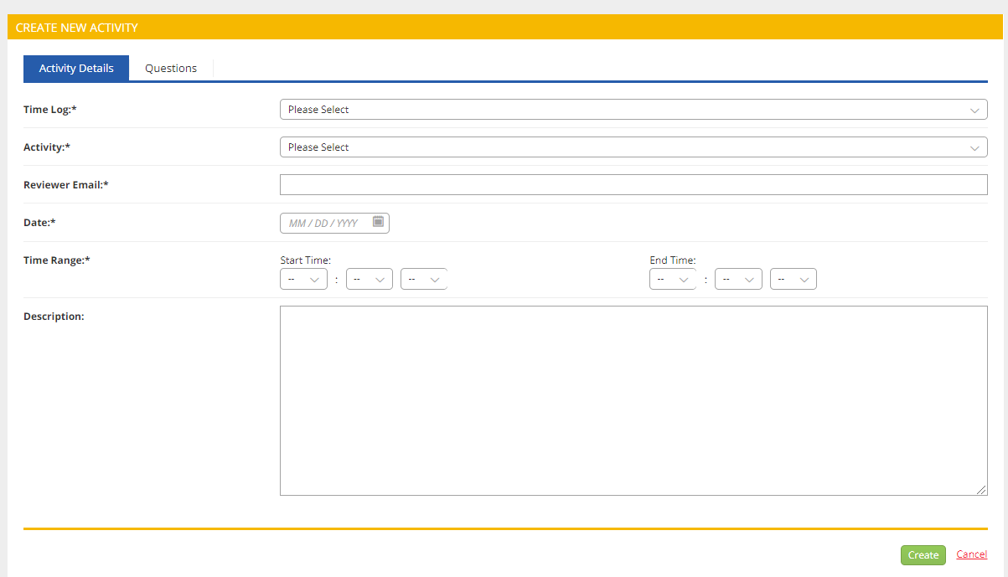

Field Instructor Tk20 Time Log to approve (Sample)

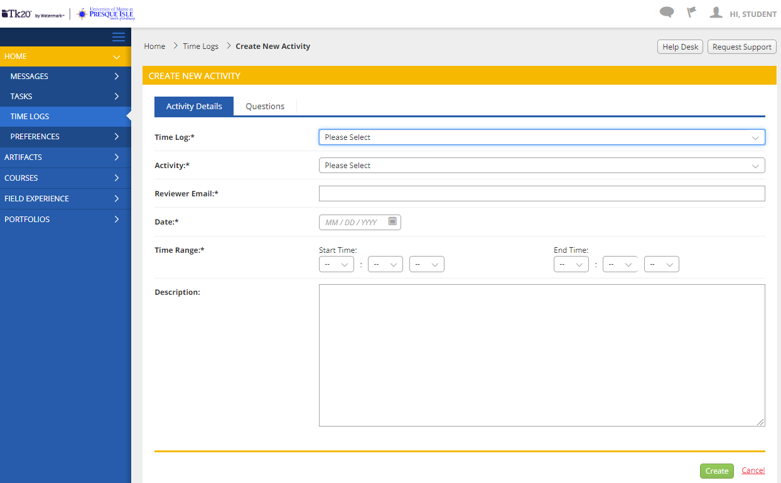

# Fall Semester Papers

## Student Assessment and Learning Plan

An important aspect of social work practice is planning with a client system the goals to be achieved through an evidence-based intervention method. Likewise, it is important for each student to plan educational goals and objectives and how these might be achieved within the field practicum. In accordance with CSWE core competencies will be used to assess the educational outcome performance of each student and the UMPI BSW Program overall. Competencies are measurable practice behaviors that are comprised of knowledge, values, and skills. The goal of the outcome approach is to demonstrate the integration and application of the competencies in practice with individuals, families, groups, organizations, and communities.

The general purpose of SWK 494A and SWK 494B, the Field Practicum in Social Work I and II is to provide the student with an opportunity to integrate and apply knowledge derived from the social work curriculum in an agency setting. This assignment provides an opportunity for the student to structure the field experience to integrate these competencies and practice behaviors with individual tasks and activities which meet the student’s goals and are realistic for the practicum agency site.

There are three parts to the assignment:

1. An assessment of the student and Field Practicum learning situation
2. Learning plan
3. Progress report (in seminar class)

**Due date: Oct 6 and Feb. 16**

**PART A:** **Assessment**

Assess your current level of functioning relative to the following questions:

1. Considering generalist social work practice, what do you perceive as strengths and weaknesses of the theory? What brings you to these conclusions?
2. What relevant knowledge and personal qualities do you bring to your field placement?
3. What social work roles have you had experience with thus far in your field placement? Are there roles in the agency that you identify with?
4. All social work practice involves similar tasks (data collection, assessment, intervention planning, etc.). In which task areas do you need additional knowledge or skills?
5. What coping methods do you utilize in working through professional and personal conflicts? What resources do you have available to you either within or outside of the agency to assist or support you in dealing with problem situations?
6. Describe the nature of your relationship with the agency Field Instructor and discuss the elements of this relationship that have been particularly helpful to you.
7. Describe your input in determining both the method and content of your meetings with your Field Instructor. Discuss any barriers to communication with your Field Instructor or other problems in working together.
8. Discuss the nature of your relationships with agency personnel other than your Field Instructor.
9. Discuss the specific areas of knowledge that are necessary for social work practice within your agency. Consider biological, psychological, social and cultural knowledge. Explain how you are obtaining this needed knowledge and identify the resources available to you.
10. Discuss the types of learning experiences that might be available to you  
    in the agency.

**PART B: Learning Plan**

For this part of the assignment the student should carefully review the information presented in the self-assessment, Part A. This information should then be analyzed and a brief summary written. The summary should provide the basis for forming learning goals, objectives, and tasks for the Field Practicum experience. It should include discussion of any barriers to the student’s work in the agency. There needs to be a goal for each CSWE Competency and tasks which indicate how you will accomplish the goal at your field placement. Each goal should have tasks which can be accomplished within this semester; thus, the wording may be “beginning to assess”, or “attending family team meetings”

The learning plan will be used with the evaluation form to determine the student’s strengths, areas to improve and progress:

1. Demonstrate Ethical and Professional Behavior.

* Strengths:
* Needs Improvement:

1. Advance Human Rights and Social, Racial, Economic, and Environmental Justice.

* Strengths:
* Needs Improvement:

1. Engage Anti-Racism, Diversity, Equity, and Inclusion in Practice.
   * Strengths:
   * Needs Improvement:
2. Engage in Practice-Informed Research and Research-Informed Practice.

* Strengths:
* Needs Improvement:

1. Engage in Policy Practice.
   * Strengths:
   * Needs Improvement:
2. Engage in Individuals, Families, Groups, Organizations, and Communities.
   * Strengths:
   * Needs Improvement:
3. Assess Individuals, Families, Groups, Organizations, and Communities.
   * Strengths:
   * Needs Improvement:
4. Intervene with Individuals, Families, Groups, Organizations, and Communities.
   * Strengths:
   * Needs Improvement:
5. Evaluate Practice with Individuals, Families, Groups, Organizations, and Communities.
   * Strengths:
   * Needs Improvement:

BSW Student Name (Print): _______________________________________________________

BSW Student Signature: _________________________________________________________

Field Instructor Name (Print):­­­­­­ _____________________________________________________

Field Instructor signature: ________________________________________________________

Agency: ______________________________________________________________________

Date of Review: ________________________________________________________________

**PART C:** **The Progress Report** (Given orally to the seminar participants)

This part of the assignment is due during the seminar on a periodic basis and serves as an update to the plan for the work to be completed during the spring semester. The student needs to address his/her progress with one competency each week during his/her individual discussion time in seminar. Over the semester all the competencies should be addressed at least once. The student should review the progress made on each competency and note any changes in the tasks. Tasks may be added or deleted reflecting the changing nature of the learning process. The outcome of each competency will be an aspect of the Revised Learning Plan to be written in the Spring semester.

# Spring Semester Papers

## Revised Student Assessment and Learning Plan

As the second semester of field placement is entered, it is important for each student to reflect on the first semester and assess the learning needs for this semester. It is important to consider areas of accomplishment from the first semester and areas which have been identified as needing improvement. Review the learning goals from the first semester. Conduct a qualitative analysis by indicating to what degree you have met the goals and completed the tasks associated with them. If tasks for a goal have been met, add new tasks which reflect the progress which has been accomplished and will continue to assist the student in developing knowledge, values and skills. If tasks have not been met, evaluate whether this task is achievable and whether to develop new tasks or refine this task to assist in accomplishing this goal.

If the student wants to be able to participate in a particular activity at the field practicum agency, make it part of the learning plan and discuss it with the field instructor.

# Field Education Evaluation

Evaluation of student performance in the Practicum is an ongoing collaborative effort involving the student, the Field Instructor and the Director of Field Education. The evaluation is reflective of the field CSWE core competencies and practice behaviors as well as the student’s individual objectives, the agency’s objectives and setting opportunities.

The student needs to complete a minimum of 500 hours total over two semesters in the Field Practice. This is accomplished by having the students at the Practicum site for 16 to 18 hours per week for the length of the semester. This is usually handled with two full days (Mondays and Wednesdays) per week. After looking at the agency’s needs and the student’s needs, other arrangements can be made by a cooperative decision between the Field Instructor, the student, and the Director of Field Education.

If a student misses hours at the Field Practicum, for whatever reason, it is the student’s responsibility to make arrangements to fulfill these hours. If the student realizes he/she needs to continue the practicum past the end of the semester, arrangements and a plan need to be developed with the Field Instructor and the Director of Field Education. In the event the hours do not total 500 by the end of the spring semester and the student has not shown effort to complete the hours nor has developed a plan to complete the hours, a failing grade is given.

**Grading Criteria**

It is difficult to establish an absolute, objective basis for grading in a Field Practicum course. The logs are learning and communicative tools, and as such are not graded. This reflects the total level of learning and performance by the student. If logs are not completed, the student will receive a failing grade.

The learning plan is a learning tool for the student and field instructor to use to assist in the educational experience of the student, and as such will not be graded. If the learning plan is not completed, unsatisfactory, or late, the final grade will be reduced.

A portion of the student’s grade is dependent upon the evaluations completed by the student and field instructor. Each student should become familiar with the elements of the evaluation. A mid-semester conference is held with the student, the field instructor, and the Director of Field Education to discuss the learning plan developed by the student and to determine how the placement is going. At the end of the semester, the student and the field instructor each fill out the evaluation form, then collaborate together on the final evaluation. The final copy is sent to the Director of Field Education.

The final grade will be determined by the Director of Field Education, who will consider the evaluation form and logs. Students may appeal the grading decision by following the student grievance procedure set forth by the university.

Field Practicum Evaluations 50%

Logs and Journals 25%

Learning Plan 25%

# Senior BSW Field Evaluation (FE Artifact)

***For more information on the scoring you can refer to the SWK Program Field Practicum Manual for the Performance Measure scale under the Student Progress and Evaluation Form. Once this form is complete please print, sign and return to the Director of BSW Field Education.***



###### BSW Field Evaluation for field instructors to complete.

###### BSW Field Evaluation for field instructors to complete.BSW Field Evaluation for field instructors to complete.

###### BSW Field Evaluation for field instructors to complete.

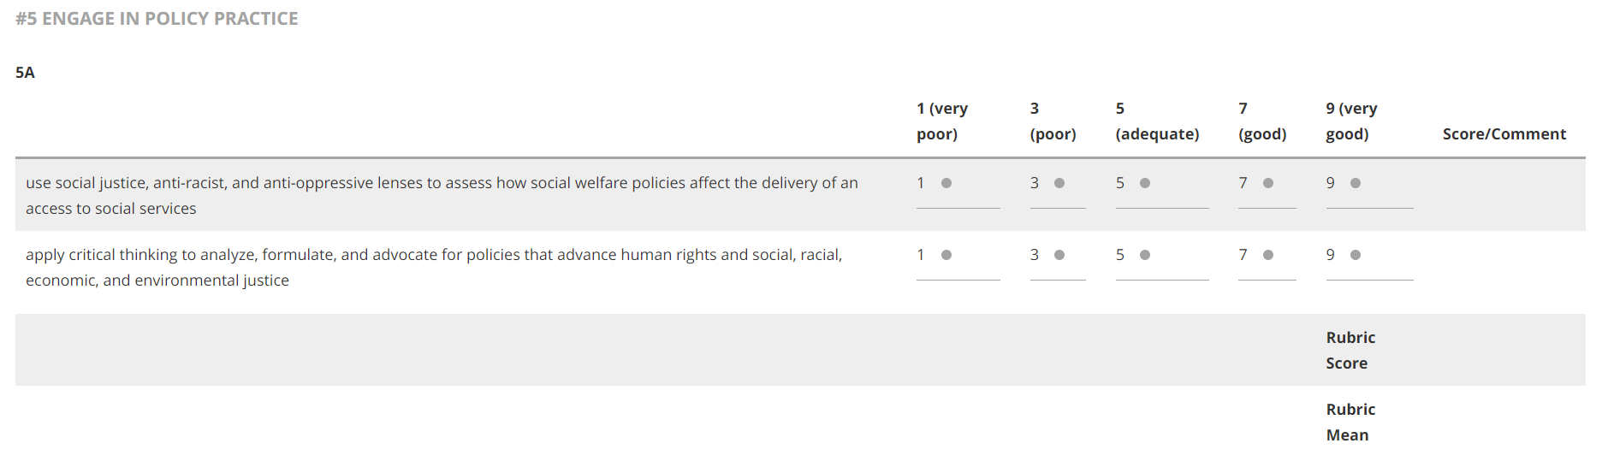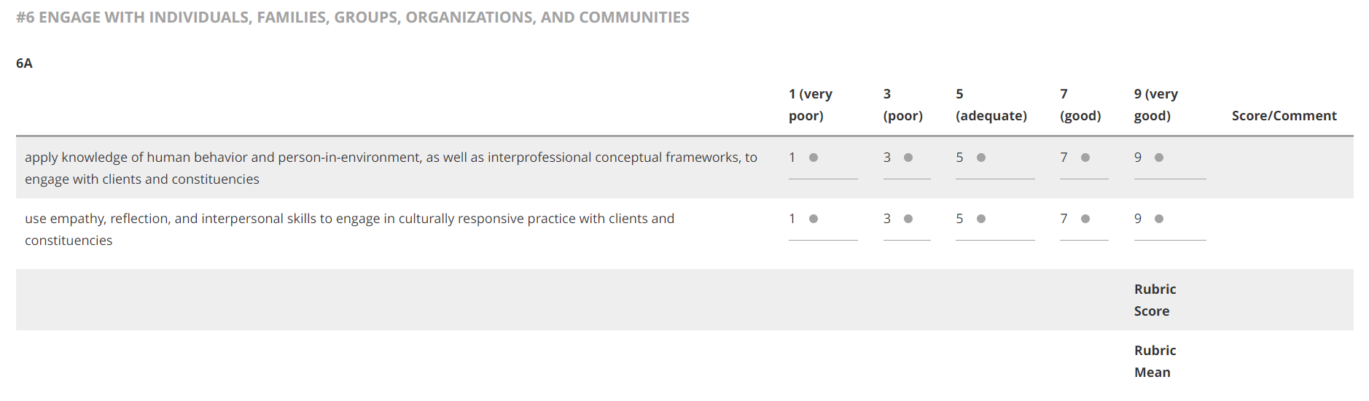

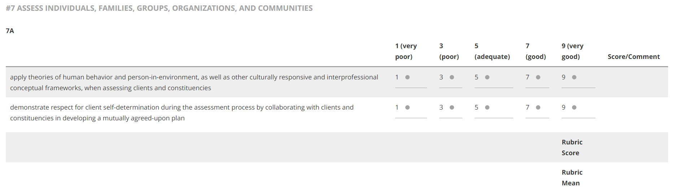

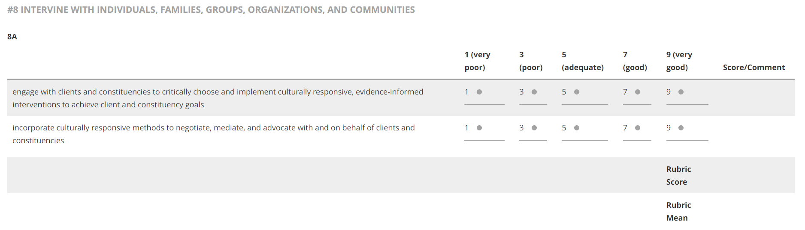

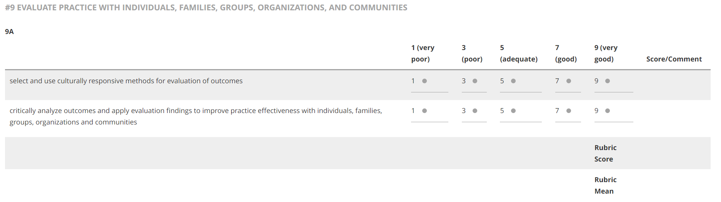

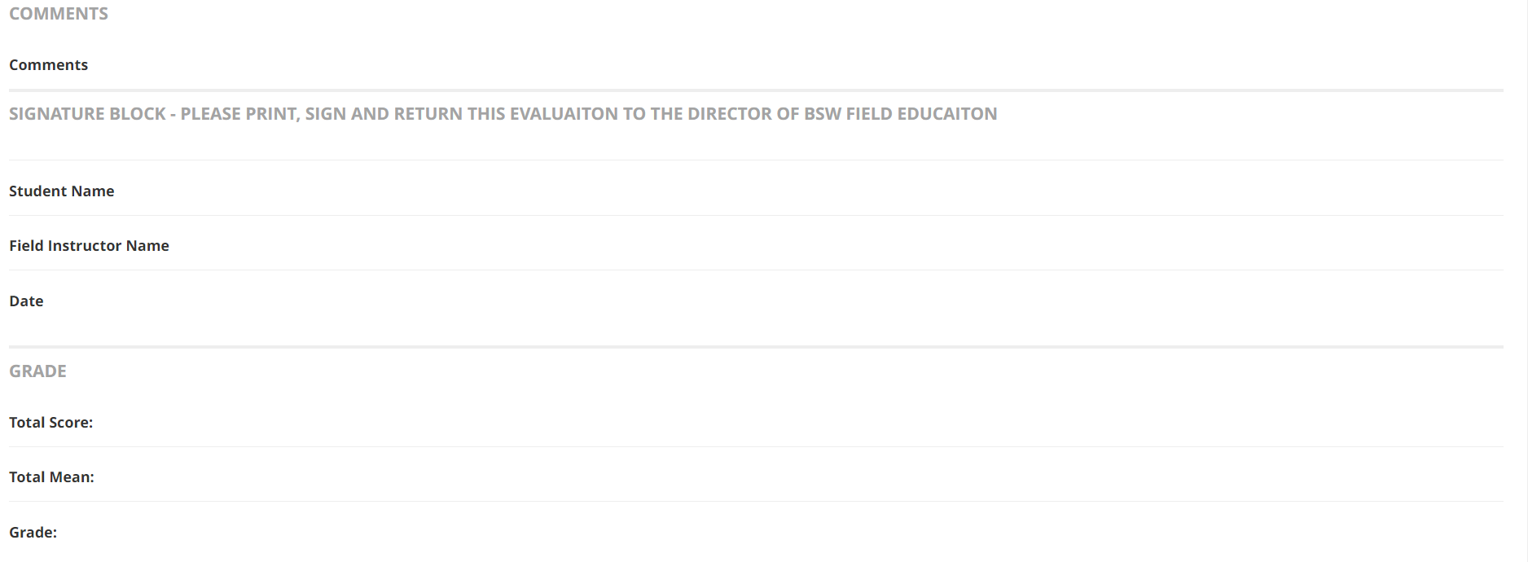

**Seminar Assignments (Student form in Tk20)**

The following is a preview of the "Basic" sub-tab you have created for your artifact template. In addition to this, the user will see the "Feedback" sub-tab.

***Please upload your Assignments in the areas below. You can upload them or drag and drop. You do not need to do anything with the Title or Description area on the top of this form.***

Title:*



Description:



SHARED ASSIGNMENTS

*Please upload your four shared assignments*

Assignment 1

Select File

Drag and drop file here

Assignment 2

Select File

Drag and drop file here

Assignment 3

Select File

Drag and drop file here

Assignment 4

Select File

Drag and drop file here

Update

**Seminar Assignments (Field Instructor in Tk20)**

***Once you have reviewed the student assignments please give feedback and rate the overall rating.***

SEMINAR ASSIGNMENT FIELD INSTRUCTOR COMMENTS

Comments on Seminar Assignments Submitted



Developing Potential and Overall Appraisal Please include a brief description of the student as a potential helping person at beginning of Field Practicum and at the present time.



OVERALL EVALUATION

Overall Evaluation Please select the correct level

| Overall Evaluation Please select the correct level | | | | | | |
| --- | --- | --- | --- | --- | --- | --- |
|  | **Very High Level** | **Above Acceptable Level** | **Acceptable Level** | **Below Acceptable Level** | **Unacceptable** | **Score** |
| Select One  NA Not applicable | 5 | 4 | 3 | 2 | 1 |  |
|  |  |  |  |  | Rubric Score: |  |
|  |  |  |  |  | Rubric Mean: |  |

SIGNATURE BLOCK - PLEASE PRINT, SIGN AND RETURN THIS EVALUATION TO THE DIRECTOR OF THE BSW FIELD EDUCATION

Student Name



Field Instructor Name



Date



GRADE

Total Score:



Total Mean:



**Student Progress and Evaluation Form**

Please base your assessment of how well the BSW Field/Practicum Student demonstrates their ability related to the performance of the practice behavior using the rating scale below.

|  |  |  |  |
| --- | --- | --- | --- |
| Scale | Performance Measure | Description | Definition |
| 9 | Mastered Performance | The intern/student shows effective and innovative application of the knowledge, values, and skills related to the performance of the practice behavior. | Mastered: “somebody highly skilled at something.” Mastered performance is demonstration of knowledge, values, and skills of the practice behavior at high levels. |
| 7 | Superior Performance | The intern/student shows superior application of the knowledge, values, and skills related to the performance of the practice behavior. | Superior ;”surpasses competent in one or more ways.” Superior performance is demonstration of knowledge, values, and skills where all components of the practice behavior are included. |
| 5 | Competent Performance | The intern/student shows competent application of the knowledge, values, and skills related to the performance of the practice behavior. | Competent: ”having enough skill or ability to do something well.” Competent performance is demonstrated of knowledge, values, and skills where all components of the practice behavior are included, but at the beginning or rudimentary level. |
| 3 | Inadequate Performance | The intern/student shows beginning application of the knowledge, skills, or dispositions related to the performance of the practice behavior. | Inadequate: ”failing to reach an expected or required level or standard. “Inadequate performance is demonstration of knowledge, values, and skills where one or more of the components of the practice behavior are missing. |
| 1 | Lacking Performance | The intern/student has not demonstrated application of the knowledge, values and skills related to the performance of the practice behavior. | Lacking: ”missing, not present or available.” Lacking performance is the inability to demonstrate any of the components of the knowledge, values, or skills related to the practice behavior. |
| 0 | Not Observed | The intern/student has not had the opportunity to demonstrate the knowledge, values, and skills related to the performance of the practice behavior. | Observed: "to see or notice something, especially while watching carefully.” There was no observation of the performance of the practice behavior. |

©BEAP (Buchan, V.V.; Christenson, B.L.; Delong-Hamilton, T.; Foster, D.J.; Gerritsen-McKane, R.; Gilbert, A.; Hull, G.H.; Rodenhiser, R.W.; Rogers, J.P. Smith, M.L., 2009).

(Special assistance from Clouser, B.) Revised 10-22-09

# Policy for Field Practicum Site Selection

The field practicum is an integral component of the curriculum in social work.

The selection of field practicum sites and field instructors follow CSWE guidelines. The field practicum site needs to be able to provide an opportunity for the student to apply foundation knowledge, skills, values and ethics to practice.

As the CSWE Curriculum Policy statement indicates, the field practicum site must provide the student with opportunities for:

1. The development of an awareness of self in the process of intervention.
2. Supervised practice experience in the application of knowledge, values and ethics, and practice skills to enhance the wellbeing of people and to work toward the amelioration of environmental conditions that affect people adversely.
3. Use of oral and written professional communications which are consistent with the language of the practicum setting and of the profession.
4. Use of professional supervision to enhance learning.
5. Critical assessment, implementation, and evaluation of agency policy within ethical guidelines.

New agencies have many aspects to develop, address and contend with during

the first year in order to provide ethical practice. These agencies must have provided services for at least a year before being considered as a field practicum site. Agencies under NASW sanction will not be considered.

Field practicum instructors are vital to the field practicum experience. The field practicum instructors should hold a CSWE-accredited baccalaureate or Master’s social work degree with at least 2 years post degree experience. This affirms the continuation of social work knowledge, values, and philosophy from the classroom to the field. However, there are other degrees that qualify:

1. Preferred: MSW from an accredited university, with 2 years of experience
2. BSW from an accredited university, with 2 years of experience.
3. Other degree/licensure than Social Work; however, the Director of Field Education is required to meet with the student weekly throughout their field placement.

The rural area in which we practice has limited agencies, services, and field instructors. When an agency does not have a field instructor with a CSWE accredited baccalaureate or Master’s social work degree, then the University Director of Field Education will be responsible for the supervision of the student to ensure that a social work perspective is provided.

Employees who have been at their position for less than one year will not be considered as field instructors. Individuals whose social work license is on probation, under suspension, or under NASW sanction are not qualified to be field instructors.

Each academic year an orientation is conducted by the Director of Field Education for the field instructors. This orientation includes a review of the field practicum manual, evaluation procedures, ethics, the program philosophy and social work perspective, respecting individual student strengths and limitations, CSWE competencies, student safety, and the continual contact with the Director of Field Education.

**Recommendations for Orientation of BSW Students**

The Field Practicum is a vital part of the Social Work Program and is the aspect which develops social work professionals versus individuals with a college degree. Thus, the Field Instructors are very important. Students will be looking to the Field Instructors as role models, mentors, teachers, supervisors, and confidantes. Initially, students are apt to be nervous, uncomfortable and need continual guidance. The orientation which the Field Instructors provide a student will help to decrease the student’s apprehension and increase their ability to function more independently.

The following are some suggestions for orientation:

1. Have a space available for the student to work. This reflects the agency’s desire to have the person there and relays a sense of respect.
2. Give a tour of the agency.
3. Introduce the student to other agency staff and explain the organization hierarchy. Review the agency’s policies.
4. Review the forms used and the expectations for documentation.
5. Develop a timetable, with increasing expectations, for the semester’s work.
6. Schedule times for supervision.

# Memorandum Of Agreement: BSW Program Field Placement

The parties to this Agreement are the Bachelor of Social Work Program of the University of Maine at Presque Isle (BSW) and: _______________________________.

The Bachelor of Social Work Program, in placing students at the above named agency from __________________________ to ______________________________

agrees to the following responsibilities:

The BSW Program will:

1. Assess and screen students with regard to readiness for field placement.
2. With the knowledge of the student, inform the agency of any major area of concern regarding a student’s readiness for field placement.
3. Provide students with knowledge of their general responsibilities for the field placement.
4. Develop objectives for the field learning experience.
5. Provide materials to assist field instructors with their role and to enhance the integration of the field and academic learning experience.
6. Provide students with the knowledge and guidelines for professional conduct articulated in the NASW Code of Ethics.

In accepting student for field placement, the agency agrees to the following responsibilities:

1. Assign a qualified field instructor for the student. This involves assigning a field instructor with knowledge and skill in Social Work and sufficient time and resources to supervise a student.
2. Provide for adequate field instruction. The field instructor is involved by:
   1. Meeting weekly with the student (an average time would be one hour per week, although this will vary over the course of the year and, in addition, will depend on the individual needs of the student and the nature of the field assignments).
   2. Developing educationally sound learning experiences relevant to the field objectives of the Bachelor of Social Work Program and the individual student’s objectives and needs (the experiences should be of increasing complexity with increasing level of student autonomy as the semester progresses).
   3. Providing the Bachelor of Social Work Program with a resume.
3. Provide for adequate working space and other resources as needed by the student for the performance of the field assignments.
4. Treat students in a nondiscriminatory way with regard to race, ethnicity, religion, gender, age, sexual orientation, or handicapping condition.
5. Conduct the programs and services of the agency in a manner consistent with the guidelines for professional conduct articulated in the NASW Code of Ethics.

It is understood that field placement students are not University or Agency employees and, therefore, are not covered by Social Security, unemployment, or workers’ compensation. The Agency shall be responsible for arranging immediate care in case of an accident or illness of a student, but it is not responsible for the costs involved, follow-up care, or hospitalization. The medical costs incurred shall be the responsibility of the student.

_________________________________­­­________ ________________

Agency Administrator or Representative Date

_________________________________­­­________ ________________

Agency Field Instructor Date

_________________________________­­­________ ________________

Director of Field Education Date

_________________________________­­­________ ________________

Director of Bachelor of Social Work Program Date

Agency Name: _____________________________________­­____________________

Student Name: _________________________________________________________

# Supervision

The purpose of the supervision is to help guide the students in putting their knowledge and skills together in a professional manner. Each student will bring their own unique personality, experience, and perception of course material to the Practicum. These differences among students should be respected and the supervision used to encourage and develop the student’s greatest potential as a professional.

Supervision should be provided for one to one and one-half hours weekly. Both positive and negative aspects of a student’s performance should be addressed. Some suggestions for supervision would include case material, approaches to specific situations, social work issues, and feedback on style and integration of knowledge and skill. The student should take an active role in determining the agenda for supervision.

By working with others, many professionals’ own problems and issues come to the forefront. It is a continual process of personal change and growth to be able to keep one’s personal issues separate from the clients. The Field Instructor and Field Director can be helpful to the student in this area. It is important for the student to be able to identify what he/she is feeling and why, when working with clients. It is appropriate to discuss this information with the Field Instructor or the Field Director to help gain perspective and understanding.

If the Field Instructor realizes there are problems with a student, the Director of Field Education should be notified. Together a plan will be developed to help address the issues.

Preferably, the supervision should be provided by a professional with a degree in social work. If the student’s immediate Field Instructor does not have a degree in social work but is supervised by a social worker or the agency has a social worker as a consultant, this is acceptable. The student should meet periodically with the social worker to obtain a social work perspective concerning the work in the field. Alternatively field seminar instructors can add additional field instruction time to the end of seminar classes to provide supervision for students without a qualified field instructor at their field setting.

# Confidentiality

The human service professions deal with sensitive information from individuals. This information should be handled with respect, which includes strict policies, laws and ethics about confidentiality. It is the responsibility of each social work student to become aware of the policies regarding confidentiality for the Field Practicum agency. Some case material will be used in the courses taken concurrently with the Practicum. Thus, the student needs to clarify, with the Field Instructor, the procedure to obtain the agency’s consent, the client’s written consent, and how to de-identify information before using case material or agency records for class papers.

At any time, if the student breaches a client’s confidentiality, inform the Field Instructor immediately so corrective measures can be implemented.

The preservation of confidentiality is a crucial element of social work practice. The issue of confidentiality is addressed in the social work curriculum, and it should be an ongoing topic of supervision during the Field Practicum. Learning both the overt and subtle ways in which client confidentiality is violated is important to the practice of social work. The agency’s policy on confidentiality should be reviewed with the student and since some case material will need to be used for courses taken concurrently, a policy for this procedure should be discussed.

# Field Setting Evaluation

The Field Work Setting:

1. Provides space for the student 5 4 3 2 1 NA
2. Provides access to a computer 5 4 3 2 1 NA
3. Provides access to client charts 5 4 3 2 1 NA
4. Includes student in staff training and development 5 4 3 2 1 NA
5. Provides opportunity for generalist practice with:

Individuals 5 4 3 2 1 NA

Families 5 4 3 2 1 NA

Groups 5 4 3 2 1 NA

Community 5 4 3 2 1 NA

Policy 5 4 3 2 1 NA

Research 5 4 3 2 1 NA

Overall agency rating 5 4 3 2 1 NA

Comments:

The Field Instructor:

1. Oriented the student to the field setting 5 4 3 2 1 NA
2. Explained expectations to student 5 4 3 2 1 NA
3. Provided supervision on a regular basis 5 4 3 2 1 NA
4. Was available to the student 5 4 3 2 1 NA
5. Provided instruction for documentation 5 4 3 2 1 NA
6. Modeled professional generalist practice 5 4 3 2 1 NA

Overall field instructor rating 5 4 3 2 1 NA

Comments:

# Classroom Conduct and Comportment

Social work is a profession, and an aspect of social work education is developing professional behavior. This begins in the classroom with how students conduct themselves and relate to classmates and the instructor.

Expected behavior in addition to punctual attendance:

Students will show respect to all persons, whether classmates, instructor, or guest speakers. Respect means paying attention to anyone who is speaking, not talking on the side, sleeping, completing homework, or other distracting activity.

Expressing opposite opinions and views is encouraged. Students will participate in a manner which allows all individuals to express their views. All opinions should be expressed openly. People should be allowed to finish statements and not be interrupted, and facial statements or body language, which reflects disapproval, should not be conveyed without an explanation.

Technology manners: Texting during class, answering cell phones during class, cell phone photos or videos in class are disrespectful to the entire class. Audio or video taping a lecture, participation, or activities without permission of the instructor is a breach of confidentiality and not allowed. The use of laptops during class is distracting for everyone. A letter from Student Support Services is needed to indicate if this is an accommodation needed for a student.

If you are expecting a call due to a family issue, such as a sick child, inform the instructor before the class begins and step out of class to accept the call.

Role playing is an important aspect of the social work courses. Photographing and/or videoing these role plays by a classmate without the participants’ permission is a violation of confidentiality and is not allowed.

The Field Practicum is an aspect of social work education when students actually use the skills learned in the classroom. Professionalism and professional behavior is expected not only in the classroom, but in the field practicum as well. It is an aspect of the field practicum evaluation and will be addressed if there are concerns.

Disruptive behaviors of any nature are unprofessional, unacceptable and will be addressed. This includes but not limited to yelling, name calling, and threatening behavior. The University of Maine Presque Isle has a student code of conduct which all students are expected to follow.

# Insurance Information

Insurance coverage for social work interns will vary from agency to agency. As the Field Instructor, you should become familiar with the coverage in your particular agency for students. Please check into the different aspects that the placement may address, i.e., transporting clients, professional liability, and workers’ compensation in the event of a Practicum-related injury or illness. Please discuss this information with the student and determine what situations should be avoided due to lack of coverage or potential danger for the student, i.e., restraining a client or exposure to an infectious disease.

Malpractice insurance for the individual professional is becoming good practice. Each social work student is covered by the University’s broad professional liability policy and has the option to purchase individual malpractice insurance.

Each student is responsible for their own medical care and coverage for medical care. The agency of field placement shall be responsible for arranging immediate care in case of an accident or illness of student, but it is not responsible for the costs involved, follow-up care, or hospitalization.

It is understood that field placement students are not University or Agency employees and, therefore, are not covered by Social Security, unemployment, or workers’ compensation.

Good communication and knowledge is the best insurance information for the agency and the student. If a problem does arise, please notify the Field Director immediately.

**UNIVERSITY OF MAINE AT PRESQUE ISLE: Bachelor of Social Work Program**

# Notice Of Risks To Student Participants

Participation in the Bachelor of Social Work Program exposes you, the student, to certain inherent risks and dangers of which the student must be aware. Such dangers include: physical injury from clients or from unsafe environments in which they may reside; physical illness from exposure to disease; and emotional distress related to stressful situations. In addition, there may be other risks and dangers associated with your participation in this program, some of which are easy to identify, some not. You must understand that the University cannot guarantee your safety or otherwise protect you during participation in this program.

It is understood that field placement students are not University or Agency employees and, therefore, are not covered by Social Security, unemployment, or workers’ compensation. The Agency shall be responsible for arranging immediate care in case of an accident or illness of a student, but it is not responsible for the costs involved, follow-up care, or hospitalization. The medical costs incurred shall be the responsibility of the student.

You must remain alert to the presence of these risks and to take every reasonable precaution to protect yourself from harm. You must know and understand your work program and your work environment.

As a condition of participation in this program, you are required to report immediately to your field instructor and field faculty liaison any incidents or developments of which you become aware that pose any danger to you or other students.

A C K N O W L E D G E M E N T

I have read the above Notice of Risks. I understand it and agree to abide by its terms.

____________________ ­­_________________________­­­__­­­­_____________________

Date Student Signature

# Background Check Policy

The UMPI BSW Program requires a background check of students for progression within the program. The field of social workplaces people in positions which work with vulnerable populations. If students’ past or present actions may place these individuals at risk, it is the responsibility of the BSW Program and the University to advise such students into another academic field of study. As an indication of integrity and professionalism the student will be expected to inform the BSW faculty during the BSW entrance interview of any criminal circumstances.

Some criminal activity or circumstances may not harm the client population, but it may limit entry into or field placement options. Past and present actions could impact the student’s ability to become licensed as a social worker. The UMPI BSW Program lays no claim to an assurance of a student’s ability to become licensed or the equivalent of licensure.

The student will be required to purchase a recent background check before entering the senior field practicum. This information will be kept in the student’s academic record in the Director of Field Education’s Office until completion of the BSW Program or the student leaves the program, at which time it will be shredded. The Director of Field Education and the student will decide together what and how information, if any, needs to be shared with the field instructor.

# Field Education Seminar

The purpose of the seminar is to provide students with the opportunity to discuss concerns from their Practicums, to connect academic material with practical experience, and to present information to help achieve the Social Work Core Competencies. The seminar structure will be determined by students and faculty. It should include open discussion, student presentations, and role plays.

Each student will have an opportunity to facilitate the 3-hour seminar. It is expected the student facilitator will lead the seminar group and be prepared with a topic for discussion. This can include printed information, activities, role playing, short video, or a stimulating question. The student facilitator needs to manage the time so that each student can discuss any placement issues each week in addition to the facilitator’s topic.

The spring semester the student facilitator presents a de-identified case from the field placement and leads a “team meeting”. Select a case and present the history, assessment, interventions, and barriers encountered. Develop a list of questions concerning the case which the seminar students are to discuss. This can be used to assist the student develop ideas in working with the client and provide information concerning resources for the agency and clients.

# Appendix A: NASW Code of Ethics

**CODE OF ETHICS OF THE NATIONAL ASSOCIATION OF SOCIAL WORKERS THE NATIONAL ASSOCIATION OF SOCIAL WORKERS**

The National Association of Social Workers is the largest professional social work organization in the world, with more than 150,000 members. NASW's four primary functions include professional development of its members; creation and maintenance of professional standards for social work practice and social services; professional actions to advance sound social policies and programs; and provision of membership services.

NASW membership is available at reduced cost to students enrolled in accredited baccalaureate social welfare programs. As part of its membership package, students receive subscriptions to the bi-monthly journal Social Work, the monthly NASW News/Personnel Information, and reduced cost subscriptions to Social Work Research and Abstracts and NASW periodicals and books. Student members continue to be eligible for reduced cost membership dues for the first two years after graduation provided they maintain continuous membership.

Membership applications are available on-line at [www.NASW.org](http://www.NASW.org). We strongly urge students to join and become active participants in NASW.

To find the complete Code of Ethics go to [www.NASW.org](http://www.NASW.org)

# Appendix B: Council on Social Work Education Educational Policy And Accreditation Standards (EPAS)

**FUNCTIONS OF EDUCATIONAL POLICY AND ACCREDITATION**

1. Educational Policy

The Educational Policy promotes excellence, creativity, and innovation in social work education and practice. It sets forth required content areas that relate to each other and to the purposes, knowledge, and values of the profession. Programs of social work education are offered at the baccalaureate, master’s, and doctoral levels. Baccalaureate and master’s programs are accredited by CSWE. This document supersedes all prior statements of curriculum policy for baccalaureate and master’s program levels.

1. Accreditation

Accreditation ensures that the quality of professional programs merits public confidence. The Accreditation Standards establish basic requirements for baccalaureate and master’s levels. Accreditation Standards pertain to the following program elements:

* Mission, goals and objectives
* Curriculum
* Governance, structure, and resources
* Faculty
* Student professional development
* Nondiscrimination and human diversity
* Program renewal
* Program assessment and continuous improvement

1. Relationship of Educational Policy to Accreditation

CSWE uses the EPAS for the accreditation of social work programs. The Educational Policy and the Accreditation Standards are conceptually integrated. Programs use Educational Policy, Section 1 as one important basis for developing program mission, goals, and objectives. Programs use Educational Policy, Section 3 to develop program objectives and Educational Policy, Sections 4 and 5 to develop content for demonstrating attainment of the objectives. The accreditation process reviews the program’s self-study document, site team report, and program response to determine compliance with the Educational Policy and Accreditation Standards. Accredited programs meet all standards.

These standards can be obtained at [www.cswe.org](http://www.cswe.org)

# Appendix C: Field Education Selection Process

**UNIVERSITY OF MAINE AT PRESQUE ISLE: BACHELOR OF SOCIAL WORK PROGRAM**

**FIELD EDUCATION SELECTION PROCESS**

The selection of a field practicum begins after a student has been accepted to the Bachelor of Social Work Program and is enrolled in Social Work Practice I and Junior Field II. The Field Director will explain the selection process at the beginning of the Junior Field II course. The process consists of the following:

1. Field Director distributes field practicum application forms, consent forms,

insurance applications, and field practicum lists.

2. Field Director and seniors describe the field practicum sites available.

3. Each student fills out the application and forms and returns them to the Field

Director the week after the presentation.

4. The Field Director will try to match each student with his/her preference. Due to limited resources, or special needs, this may not always be possible.

5. The Field Director will give each student the name of an agency, field

instructor and phone number.

6. The student is expected to contact the field instructor and set up an interview. The interview is to be used by both the student and the field instructor to determine a compatible match. The student should ask specific questions to feel

knowledgeable about what he/she would be doing and learning in this field practicum.

7. After the interview, the student gives his/her impressions and feedback to the Field Director. If the student would like to work with this particular field instructor, the Field Director will confirm this with the field instructor. If the interview revealed that the student would not like to work at this agency, the student and Field Director will discuss other options and begin the interview process again.

8. Apply for malpractice insurance. The student can apply to NASW and obtain

student insurance from NASW Trust or obtain a policy from another insurance

company. Students will not be allowed to begin the field placement until a copy of a current insurance policy is provided to the Field Director.

9. The students begin field practicum at his/her confirmed site the second week of the fall semester, if a copy of their malpractice insurance policy and background check has been given to the Field Director.

**UNIVERSITY OF MAINE AT PRESQUE ISLE: BACHELOR OF SOCIAL WORK PROGRAM**

**APPLICATION FOR FIELD EDUCATION**

Name: Student ID #:

Present

Address:

Street/P.O. Box State Zip Code

Summer Address:

(if different)

Street/P.O. Box State Zip Code

Present Telephone No.:

Summer Telephone No.:

E-mail Address:

Will you have transportation for the field Practicum? Yes No

If you do not have access to transportation, your choices for field practicum will be more limited.

Do you have any special needs or concerns which will effect a field practicum selection?

Yes No If yes, please explain:

Field Practicum preferences:

1.

2.

3.

FIELD PRACTICUMS

ELDERLY

Aroostook Area Agency on Aging – Presque Isle (need car)

Presque Isle Nursing Home

TAMC Long Term Care – Mars Hill (need car)

Caribou Nursing Home (need car)

Houlton Regional Hospital Long Term Care

**ADULT**

Personal Services of Aroostook – Presque Isle (need car)

Probation/Parole – Presque Isle or Caribou

Temporary Shelter for the Homeless – Presque Isle

Roger Randel center – Houlton (need car)

Hope and Justice – Presque Isle, Caribou, Houlton

Women, Work and Community – Presque Isle, Houlton

Job Corp – Limestone

Department of Health and Human Services:

Adult Protection- Caribou, Houlton (need car)

**CHILDREN**

Fort Fairfield School

Caribou School

Presque Isle School

Ashland School

Department of Health and Human Services:

Protective – Caribou, Houlton (need car)

Support Services

Adoption

Department of Justice: Probation/Parole – Presque Isle, Caribou (need car)

Community Health and Counseling – Caribou, Houlton (need car)

WINGS – Caribou (need car)

AMHC – Children’s Behavioral Health Home/case management, Home and Community Treatment – Fort Kent, Madawaska, Caribou, Presque Isle, Houlton (need car)

**HEALTH**

Cary Medical Center – Caribou (need car)

Visiting Nurses of Aroostook – Caribou, Houlton (need car)

Northern Light/A.R. Gould (aka:TAMC) – Presque Isle

Houlton Regional Hospital

**MENTAL HEALTH**

AMHC: Skyhaven – Presque Isle

Community Support – Presque Isle, Caribou, Houlton, Fort Kent (need car)

Madawaska Group Home – Madawaska (need car)

Substance Abuse Program – Presque Isle, Caribou, Limestone (need car)

Emergency Services – Presque Isle, Caribou, Houlton (need car)

Adult Crisis Stabilization Unit– Presque Isle

Children’s Crises Unit – Fort Fairfield (need car)

Northern Maine Medical Center In-Patient Unit – Fort Kent (need car)

**NATIVE AMERICAN**

MicMac Health – Presque Isle

Tobique Reserve – Tobique First Nation (near Perth)

Maliseet Health – Houlton

**NEW BRUNSWICK**

Health Services – Perth (need car)

Mental Health – Perth

Vocational Board – Perth

Social Development- Woodstock, Perth

**POLITICAL**

Senator King’s Office

Senator Collin’s Office