Fall
2026
Offerings

Planning for the Future of SAGE

With your ideas and participation, we can build a SAGE program that is both informative and fun. This is a chance to gather your suggestions for new courses and explore ways to expand learning opportunities.

Reservations Required! RSVP by calling 768-9501
Email: SAGEatUMPI@outlook.com
https://sageumpi.coursestorm.com
Before September 10 at 5:00 PM

Help Plan Next Two Years

Thursday, September 24, 2026
9:30 AM to 12:00 PM
FREE Lunch served at 12:00 PM
UMPI Campus Center Multipurpose Room

All Are Welcome Bring a Guest! Help us plan the future!

Conferences and Special Programs
University of Maine at Presque Isle
181 Main Street – Presque Isle, ME 04769
Telephone: 207-768-9501
Email: sageatumpi@outlook.com
www.umpi.edu/sage

SAGE Fall 2026 Brochure/Classes

Unless noted, all classes will be held at the University of Maine at Presque Isle (UMPI) Campus Center (CC).
All classes are held in handicapped accessible classrooms/space.

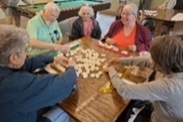
Mahjongg Club for all Skill Levels Fee: Free
Every Tuesday 1:00-3:00 PM
Sargent Family Community Center, 24 Chapman Road, Presque Isle

A beginner's Mahjongg class introduces participants to the fundamentals of the game, including tile identification, game setup, and basic rules. The course covers gameplay mechanics, including drawing and discarding tiles, as well as strategies for winning hands. Come join in on the fun!


Healthier Cooking with Lisa - The Instant Pot Fee: $5
Tuesday: October 6 10:00 AM-Noon
Cooperative Extension Office, 57 Houlton Road, Presque Isle

This hands-on cooking class introduces students to the Instant Pot as a versatile, time-saving kitchen tool. Participants will learn how it works, explore its key settings and safety features, and gain confidence using the functions. The instructor will demonstrate simple, flavorful recipes for breakfast that will include protein. Emphasis is placed on safe operation, easy cleanup, and meal planning for busy or budget-friendly kitchens. Bring your own version of electric pressure cookers if you wish. No prior experience needed—just bring curiosity and an appetite for learning.
Instructor: Lisa Fishman, Cooperative Extension Educator for many years and one of our extremely popular SAGE contributors.


Cribbage for All Fee: Free
Wednesdays: Starts on October 14 10:00 AM-Noon
Sargent Family Community Center, 24 Chapman Road, Presque Isle

Remillie Norsworthy has been playing cribbage since she was seven, just old
enough to do addition in one's head! Cribbage is an easy game to learn, but it takes strategy to play the odds in choosing the cards you keep before the communal trump card is revealed for everyone to use. We will learn what card combinations score points, how to leapfrog pegs on the board to keep track of your score, and how to try to out-think your opponent(s) when playing the pegging part of the game. We will work on strategy and play for 2, 3 and 4 players in regular cribbage, and for a single person in Chinese cribbage. No experience necessary--we'll teach ya! If participants have a cribbage board and a deck of cards at home, please bring them, but lacking a board, cribbage can be played on paper!
Instructor: Remillie Norsworthy - a retired teacher.


A Night at the Museum Fee: $10
Thursday: October 15 4:30-7:00 PM Haystack Historical Society, 1565 Main Street, Mapleton

The evening will start with a museum open house followed by a history of the Town of Mapleton. Museum will open at 4:30 and program will begin at 5:30 pm. Then a light supper will be served, which will be followed by a presentation by Dr. Dena Winslow.


Aroostook War: The Untold Story
Dive into the explosive real history behind the 1839 Aroostook War—where Maine and New Brunswick stood on the brink of international battle. This high-energy program uncovers the actual people, places, and political tensions that pushed the U.S. and England toward a third war. Based on thirty years of deep archival research, you’ll hear never-before-told stories, surprising discoveries, and dramatic events unknown to earlier historians. Experience the gripping truth of the conflict that reshaped the region forever—and leave with a whole new understanding of northern Maine’s past.
Instructor: Dr. Dena L Winslow, a well-known historian and writer, grew up in Mapleton, Maine. Her latest book about the Aroostook War was published in 2026.


The Origins of the US Pledge of Allegiance and the National Anthem as

You’ve Never Seen It! Fee: Free
Monday: October 19 6:00-8:00 PM

In celebration of America's Semiquincentennial and because immigration is such a hot topic today, this is a look at the origins of the Pledge of Allegiance AND a short video on the National Anthem 'as you have never seen it!’
Instructor: Kimberly Smith has been with the Presque Isle Historical Society since 2006 and has received several awards for her work for the society.

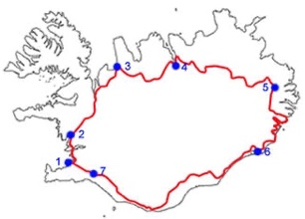
Iceland the Country of Fire and Ice Fee: $5
Thursday: October 29 10:00 AM-Noon

At the end of May I took a week-long tour of the country of Iceland. The tour had eight of us (from all over the world) in a van with a tour guide that drove around the entire country visiting sites that were so incredible. Lots of pictures and lots of stories will be shared along with unknown facts and discoveries about Iceland that I learned.
Instructor: Dennis Koch, retired from higher education and have spent the last 12 years volunteering, traveling, and still trying to figure out what is next.


Applied AI: How AI Can Assist You Fee: $5
Wednesday: November 4, 11, 18, & 25 9:00-10:15 AM
Location: TBA

In this class, we will explore how tools like ChatGPT and other chatbots can help with writing emails and letters, planning meals and managing grocery lists, researching health topics before doctor visits, organizing travel plans, learning new hobbies, and more. No technical background required, just curiosity! Each session builds confidence through simple, real-world examples tailored to the interests and needs of our class. You will leave with practical skills you can use right away, plus a clearer understanding of what these tools can (and cannot) do. Instructor: Assistant Professor Seth Woodman, specializing in Cybersecurity and Computer Science at the University of Maine at Presque Isle. An amazing instructor, who makes you feel so comfortable with technology

Ongoing Events and Clubs:


SAGE Book Club by ZOOM Fee: Free
Third Wednesday of the month or as noted 10:00-11:00 AM

Sep 16 - Murder in the Paperback Parlor by Ellery Adams (second in a series)
Oct 21 - The Road to Tender Hearts by Annie Hartnett
Nov 18 - Winter at the Door by Sarah Graves
Dec 16 - The Women of Chateau Lafayette by Stephanie Dray

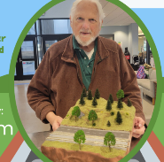
NEW!! Model Railroad Club at the Sargent Family Community Center
Fee: Free
The third Thursday, monthly 6:30 PM
Sargent Family Community Center, 24 Chapman Road, Presque Isle

This club was formed for anyone enthusiastic about model railroading, from long-term hobbyists to those just getting started. This club will explore the rich history of model railroads while also focusing on modern designs, tools, and building techniques. Members will work together to plan and build a shared display using current materials, digital controls, and creative scenery methods. Meetings will also cover topics new collectors care about, including choosing scales, basic wiring, layout planning, maintenance, and collecting tips. The club offers a welcoming space to learn, share ideas, and enjoy the timeless fun of model railroading together. Organizer: Rick Asam

There is Always More on the Horizon!!
Always check the SAGE CourseStorm website as new classes are added along with updates and changes to current classes are made to keep you informed.
https://sageumpi.coursestorm.com

COMMUNITY EVENTS


Presque Isle Historical Society plans for October, November, and December for 250th Semiquincentennial:

Exhibits and Presentations:
- Heritage Days at the Maysville Museum
- “Women of the American Revolution: Sybil Ludington”
- “Women of the American Revolution: Deborah Sampson”
- Victorian Christmas at the 1875 Vera Estey House



Parks and Recreation Program
Check out all there is going on. Events all year long.

- Caribou Parks and Adult Recreation Program
- Sargent Family Community Center
- Francis Malcolm Science Center
- Mark and Emily Turner Memorial Library

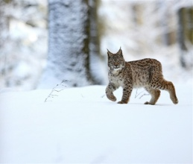
From the Friends of Aroostook National Wildlife Refuge

Do you want something new and different to do? Try cross-country skiing, snowshoeing, or walking at the Aroostook National Wildlife Refuge in Limestone. This little guy shows up once in a great while but there is always the possibility of seeing him. There are about thirteen miles of trails through pristine, boreal forest where you can breathe fresh air and enjoy the quiet. Dogs are welcome if they are on a leash. There is no fee and they are open from dawn to dusk every day.

What is SAGE?

Lifelong Learning, Lifelong Connections!

Seniors Achieving Greater Education (SAGE) welcomes intellectually curious adults, age 50 and older, who have a desire to learn in the company of others with both shared and different perspectives. SAGE brings members together in a relaxed atmosphere to discover new things about the world and themselves.

- There are no admission requirements, no exams, and no grades – only the joy of learning with others.
- All courses are planned and led by volunteers who are either SAGE members or guests.
- Course formats range from lectures to discussions and hands-on experiences.
- Topics include arts, science, current events, book club, practical skills and more.
- UMPI invites SAGE members to visit the art shows, take classes, and enjoy the cultural and sports activities on campus.
- SAGE Dining Out is a fun time to socialize once a month.

Join us and celebrate learning for life!

Visit the catalog: https://sageumpi.coursestorm.com
Visit the SAGE website: www.umpi.edu/sage
Follow on Facebook: SAGE-UMPI
Contact us at: (207) 768-9501 or sageatumpi@outlook.com

Register at https://sageumpi.coursestorm.com or mail Registration Form, annual Assumption of Risk, and Photo/Zoom Release Form with payment to SAGE, PO Box 12, Bridgewater, ME 04735. The University of Maine System is an equal opportunity institution committed to nondiscrimination.

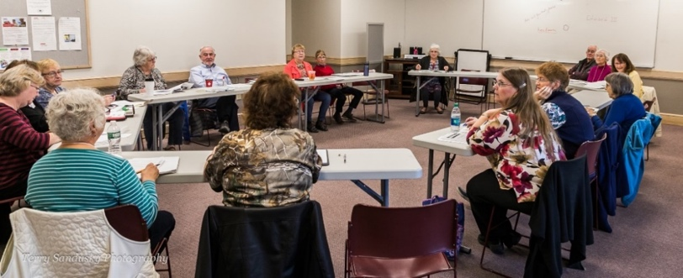


FALL 2026 REGISTRATION!
SAGE Phone (207) 768-9501

Name______________________________PhoneNumber______________________________

Address______________________________________________________________________

Email _______________________________________________________________________

How to register for a class:
- Go to https://sageumpi.coursestorm.com All classes are listed and can be paid for online with a credit card. Or, to pay by check, click “alternative payment,” finish the registration process, and mail with payment to SAGE, PO Box 12, Bridgewater, Maine 04735. We also need an Assumption of Risk and Photo Release form
- Help is available by reaching out to us at SAGEatUMPI@outlook.com or call (207) 768-9501 and leave a message.
- Membership fee must be paid to take SAGE classes. All membership payments are due annually for each year. SAGE membership gives you access to all programs offered by senior colleges across the state.

Check | Class | Fee | Owed
 | - Annual Membership for 2026 – 2027 | $25
 | - Mahjongg Club for all Skill Levels | Free
 | - Healthier Cooking with Lisa/Instant Pot | $5
 | - Cribbage for All | Free
 | - The Origins of the US Pledge of Allegiance and ‘the National Anthem as You’ve Never Seen It!’ | Free
 | - Iceland the Country of Fire and Ice | $5
 | - SAGE Book Club by ZOOM | Free
 | - A Night in the Museum and the Aroostook War | $10
 | - Applied AI: How AI Can Assist You | $5
 | - Model Railroad Club | Free
 | - Interest in volunteering with SAGE | YES | MAYBE
 | - TOTAL ENCLOSED

ASSUMPTION OF RISK
This form must be filled out to participate in any SAGE activities.
Please complete once per academic year
(September 1 to August 31).



Your Name (Please Print) ______________________________________________________________________
Mailing Address: _____________________________________________________________________________
City/Town: ________________________________ State: ______________ Zip:_________________________
In consideration of being permitted to participate in this program at the University of Maine of Presque Isle, I hereby affirm and agree to the following terms:
• I realize there are potential physical dangers and dangers to me by participating in this program, and I accept the risk involved. I realize that these physical dangers could include the possibility of broken bones and injuries.
• Therefore, I do for myself, my heirs and my personal representatives, defend, hold harmless, indemnify and release the University of Maine at Presque Isle, and all of its officers, agents and employees from and against all claims, demands, actions, and causes of actions resulting from any injuries to me, including death, which may be a result of my participation in the activities and/or field trip(s) and which results from causes which are not the fault of and negligence of the University of Maine at Presque Isle, its officers, agents, or employees during the period of my participation in this activity.
• This assumption of risk and release shall remain in effect from the date hereof to and for the period during which I am a participant in this SAGE program at the University of Maine at Presque Isle.

Signature: ___________________________________ Date: ____________________

Photo/ZOOM Release
I hereby affirm that I am (name)________________________ and without further consideration I hereby irrevocably consent that any photograph (s) which may be taken by representatives of the University of Maine at Presque Isle and/or their assignees during the SAGE program may be used for news media coverage and publicity.
Signature: _________________________________________ Date: __________________________________

I understand the ZOOM classes may be recorded to be used by people not able to attend the actual class. If I do not want my picture to appear in the recording, I will turn my camera off. I also understand that I can rename myself so even my name does not appear as an attendee.
Signature: ________________________________________ Date: ___________________________________

